LONG-TERM DYNAMICS OF A DESERT RODENT COMMUNITY: CHANGE SHAPED BY CLIMATE AND COMPETITION

By

ERICA M. CHRISTENSEN

A DISSERTATION PRESENTED TO THE GRADUATE SCHOOL  
OF THE UNIVERSITY OF FLORIDA IN PARTIAL FULFILLMENT  
OF THE REQUIREMENTS FOR THE DEGREE OF  
DOCTOR OF PHILOSOPHY

UNIVERSITY OF FLORIDA

2018

© 2018 Erica M. Christensen

To my family and friends, who always believed in me. And to Charlie, whose unbridled enthusiasm and unshakeable optimism kept me afloat.

ACKNOWLEDGMENTS

I have so many things for which to thank my adviser Dr. Morgan Ernest: for seeing potential in me and taking me on in the first place, for seemingly infinite patience as I tried new things (not always successfully), but mostly for her mentorship not only in how to do science well but how to be the kind of scientist I want to be. Special thanks also to my committee member Dr. Ethan White for years of mentorship in all things science, from encouragement to get involved in teaching workshops to advice on navigating “the system” of academia. It has truly been a journey, both figuratively and literally.

I thank all my committee members for their support and advice throughout the process, especially Dr. Denis Ribeiro do Valle for our discussions on LDA methods. Many thanks to everyone with whom I’ve had informative discussions about some very complicated topics; including Ellen Damschen for conversations on stochastic assembly, Dr. Dave Harris and Dr. Juniper Simonis for guiding me through LDA methods, and Dr. Gavin Simpson for a tremendous amount of assistance with GAMs.

Thanks to the NSF for financial support through grant DEB-1622425. Thanks also to Utah State University for the Presidential Doctoral Research Fellowship which funded my studies for my first three years.

Special thanks to all the principal investigators, grad students, and volunteers who have kept the Portal Project running for 40+ years – the amount of time and effort that has gone into collecting this unique dataset and making it open for anyone to use is truly remarkable. May it continue for another 40 years.

I thank Claire Williams and all the administrative staff of WEC, who helped me through the difficult transition of changing schools halfway through a PhD, and who do so much to support and assist all grad students in navigating our degrees.

I thank all the Weecology lab members past and present, for inspiring discussions around campfires in Arizona and moral support all along the way. I have been continuously humbled by the support and care I’ve found in grad student communities everywhere I’ve been, from USU to UNC to UF. We’re all in this together.

Finally, I thank my parents and sister for their constant support, and for cheering me on the whole way.

TABLE OF CONTENTS

page

ACKNOWLEDGMENTS 4

LIST OF TABLES 8

LIST OF FIGURES 9

LIST OF ABBREVIATIONS 11

ABSTRACT 12

CHAPTER

1 GENERAL INTRODUCTION 14

2 LONG-TERM COMMUNITY CHANGE THROUGH MULTIPLE RAPID TRANSITIONS IN A DESERT RODENT COMMUNITY 18

Introduction 18

Methods 20

Identifying Species Associations Using Latent Dirichlet Allocation 21

Quantifying When Change Occurs Using a Change-point Model 23

Results 25

Discussion 27

3 ESTABLISHED RODENT COMMUNITY DELAYS RECOVERY OF DOMINANT SPECIES FOLLOWING EXPERIMENTAL DISTURBANCE 34

Introduction 34

Site and Methods 37

Time Series Analysis Using GAMs 38

Comparing Treatments Pre-flip 39

Plant Community Analysis 40

Results and Discussion 40

4 SPECIES COMPOSITION MEDIATES RESPONSE OF A DESERT RODENT COMMUNITY TO EXTREME CLIMATE EVENTS 52

Introduction 52

Methods 54

Latent Dirichlet Allocation (LDA) 56

Change-point Model 57

Comparison of Change-points 57

Results 57

Discussion 59

5 CONCLUSIONS 70

APPENDIX

A SUPPLEMENTARY EXPLANATION OF LDA METHODS, AND DEMONSTRATION USING SIMULATED DATA SET 73

B SUPPLEMENTAL FIGURES AND TABLES FOR CHAPTER 2 77

C SUPPLEMENTAL FIGURES FOR CHAPTER 3 82

Additional Plant Community Comparisons 82

Comparing Metrics Between Treatments Pre-flip 83

D SUPPLEMENTAL FIGURES FOR CHAPTER 4 84

LIST OF REFERENCES 85

BIOGRAPHICAL SKETCH 94

LIST OF TABLES

Table page

B-1 Species relative abundances in the four community-types estimated by the LDA model. . 77

LIST OF FIGURES

Figure page

2-1 Results of LDA analysis and change point model 32

2-2 Total rodent abundance per hectare over time 33

3-1 Map of the study area showing 10 experimental plots 48

3-2 GAM model of number of kangaroo rats per plot 49

3-3 GAM model of abundances of non-kangaroo rat species per plot 50

3-4 Populations of Bailey’s pocket mouse on experimental plots. 50

3-5 Comparison of annual plant communities on different treatments 51

3-6 GAM model of community-level metabolic flux per plot 51

4-1 Results of LDA analysis on rodent community on control plots 67

4-2 Results of LDA analysis on community with kangaroo rats experimentally removed 68

4-3 Comparison of change-points from control community to change-points from experimentally altered community 69

4-4 Populations of *Chaetodipus baileyi* on control plots and kangaroo rat removal plots 69

A-1 Graphical representation of the LDA model 75

A-2 Demonstrating LDA and change-point model using simulated data 76

B-1 Histogram showing best number of topics selected by AIC procedure for 200 random seeds 78

B-2 Comparison of change-point models fit with 2, 3, 4, or 5 change-points 79

B-3 Results of LDA model fit with three community-types 80

B-4 Results of LDA model fit with four community-types. 80

B-5 Results of LDA model fit with five community-types. 81

B-6 Normalized Difference Vegetation Index (NDVI) yearly average for 1984-2015 81

C-1 Comparison of plant communities (summer and winter) on controls to plant communities on kangaroo rat removals before the treatment change in 2015. 82

C-2 Comparison of plant communities (summer and winter) on controls to plant communities on rodent removals before the treatment change in 2015. 82

C-3 Numbers of kangaroo rats per plot by treatment before treatment change 83

C-4 Numbers of non-kangaroo rat individuals per plot by treatment before treatment change 83

C-5 Total metabolic flux per plot by treatment before treatment change 83

D-1 Species population sizes around the observed change-point in April 1990 on control plots and experimental plots 84

LIST OF ABBREVIATIONS

|  |  |
| --- | --- |
| GAM  LDA  NDVI  pCCA | Generalized Additive model  Latent Dirichlet Allocation  Normalized Difference Vegetation Index  Partially constrained correspondence analysis |
|  |  |
|  |  |

Abstract of Dissertation Presented to the Graduate School  
of the University of Florida in Partial Fulfillment of the  
Requirements for the Degree of Doctor of Philosophy

LONG-TERM DYNAMICS OF A DESERT RODENT COMMUNITY: CHANGE SHAPED BY CLIMATE AND COMPETITION

By

Erica M. Christensen

December 2018

Chair: SK Morgan Ernest

Major: Wildlife Ecology and Conservation

Many communities are experiencing temporal changes in the abundances and/or identities of the species that comprise them. There have been many proposed mechanisms for this type of change, but it is often difficult to distinguish what is driving observed change in natural communities. Identifying patterns of change is an important first step toward understanding what drove past changes and what changes should be expected in the future. To address these questions, I used long-term observational data as well as experimental manipulations of a desert rodent community. Monitored monthly since 1977, this rodent community has experienced environmental changes that could impact species composition, such as gradual shrub encroachment and extreme droughts and floods. I examined patterns of long-term dynamics in this community, finding that the community experienced three rapid reorganization events separated by at least ten years. These reorganizations coincided with periods of low total rodent abundance, suggesting a link between community change and events that caused rodent mortality. An important part of the process of change may be overcoming mechanisms that impede change. In Chapter 3 I leveraged the experimental manipulations of the site to ask how species interactions may impede change. Using a set of experimental plots where either a dominant group of species was removed (kangaroo rats of the genus Dipodomys) or all rodents removed, I tested whether the existing rodent community of non-kangaroo rat species would impede recolonization by kangaroo rats when the experimental restrictions were removed. I found that plots with an established community were more resistant to invasion compared to empty plots, though the effect did not last beyond two years. In Chapter 4 I again used the experimental manipulations to determine how long-term dynamics were affected by the removal of a key group of species (kangaroo rats) from the community. Both the experimental plots and control plots were monitored for 38 years, and experienced the same environmental conditions. I found that the two communities experienced changes at different times, and whether or not an extreme climatic event resulted in community reorganization depended on the response of the numerically-dominant species in the community.

CHAPTER 1

GENERAL INTRODUCTION

In many places on the planet, the ecological template of nature is changing: temperature is increasing, nutrient distributions are changing, and habitats are being altered and fragmented (Walther 2010). Because every species has environmental conditions and resources that they prefer or require, these changes will alter the communities of species that live there. Exactly how the composition of a community will temporally track those changes, however, is less clear. There are theoretical reasons to expect both slow and rapid changes in community composition. Slow changes in communities emerge from either stochastic turnover events (Magurran and Henderson 2003, Orrock and Watling 2010) or because a species’ ability to thrive gradually improves or degrades as the environment changes, leading to niche-based turnover events (Beaugrand 2004, Tingley et al. 2009). Rapid changes in communities, or regime shifts, can emerge from intrinsic or extrinsic drivers (Williams et al. 2011). With intrinsic regime shifts, gradual changes in the environment eventually push the ecosystem past a threshold, triggering rapid shifts to a new stable state (Scheffer and Carpenter 2003). Extrinsic regime shifts occur either from niche-based tracking as the environment rapidly shifts from one state to another (e.g., shift in climate from a drier to a wetter state; Rowe 2007, Wirth et al. 2008) or via extreme events, which cause cascading changes in species populations that alter how the community recovers post-disturbance (Smith 2011). Identifying patterns of change in community structure is important for understanding the drivers of community reorganization and whether we should expect changes to occur quickly or over the span of years or decades.

In this dissertation, I explore mechanisms of change in species composition and community structure in a desert rodent community. I use data from the Portal Project, a long-term study located on 20 hectares of Chihuahuan Desert near the town of Portal, Arizona, USA (Ernest et al. 2016). Small mammal data is collected at this site on 24 permanent 50m by 50m plots, sampled at monthly intervals with no major changes in methodology since 1977. The twenty-one rodent species caught at the site consist primarily of granivorous rodents, with some insectivorous or folivorous species. This community has experienced considerable turnover in species composition through time, with only two species captured consistently at almost every survey since 1977. Further information on the site and protocol can be found in Brown (1998) and Ernest et al. (2016). The latter paper also contains the data used in this analysis.

In Chapter 2, I examine dynamics of community change over 38 years in the rodent community. Previous work at this site has found that the rodent community experienced significant changes during this time. Studies focused on long-term trends suggest that the rodent community was responding to a trend of increasing shrub cover at the site (White et al. 2004, Ernest et al. 2008). However, there are also examples of rapid turnover in response to extreme climate events (Valone et al. 1995, Thibault and Brown 2008). In this project, I examine changes in species composition and species’ relative abundances from 1977-2015 in order to identify any rapid turnover events not previously detected and to place these events in the context of gradual change. I use Latent Dirichlet Allocation (LDA) to identify patterns of species co-occurrence (i.e., “assemblages” of species) in the data and quantify how the presence of these assemblages changes over time. I then use a change-point model to identify points in time when the most dramatic changes in species composition occurred. Identifying patterns of change (i.e., slow change, rapid transitions, or periods of stability) is an important first step toward building a predictive framework around the conditions that cause community change.

Some of the results from Chapter 2 suggest that an important part of the process of change is overcoming mechanisms that impede change. Based on coexistence theory, a community in a stable state has reinforcing mechanisms that work to maintain this state (e.g., priority effects (Fukami 2015) and storage effects (Chesson 2000)). In Chapter 3, I examine the role of species interactions in impeding change, leveraging the experimental aspect of the site at Portal. Three levels of manipulation (rodent removals, kangaroo rat removals, and controls) create a patchy landscape with plots containing different rodent communities: undisturbed communities (controls), communities lacking a single genus of important seed-eaters (kangaroo rats of genus *Dipodomys*), and communities consisting of only a few transient individuals (rodent removals). In 2015, half of the kangaroo rat and rodent removal plots were converted to controls, allowing rodents to recolonize. I compare the recovery of kangaroo rat populations on newly opened rodent removal and kangaroo rat removal plots in order to test whether the established rodent community on former kangaroo rat removal plots posed a significant barrier to the behaviorally-dominant kangaroo rats recolonizing suitable habitat.

In Chapter 4, I again use the long-term experimental manipulations to investigate the role of species interactions in the patterns of change observed in Chapter 2. I use the same methods used in Chapter 2 to compare the long-term dynamics of the community on unmanipulated control plots to the dynamics of the community on kangaroo rat removal plots. Kangaroo rats are considered a key group of species in this system; they are known to have significant impacts on other granivorous rodent species (Valone and Brown 1995) and tend to be numerically dominant in the community. Both communities experience the same environmental conditions, and nearly all rodent species are present in both communities; the only difference is the role of kangaroo rats in the community. If the composition of the community is an important factor determining the sensitivity of the community to extreme climate events, we should see differences in the presence of reorganization events between the two communities. However, if species composition is not an important factor, dynamics should be synchronous.

CHAPTER 2

LONG-TERM COMMUNITY CHANGE THROUGH MULTIPLE RAPID TRANSITIONS IN A DESERT RODENT COMMUNITY

Introduction

As humans alter the template of nature[1]by increasing temperature, changing nutrient distributions, and altering land cover (Walther 2010), the composition of species living in these places also changes. Compositional changes occur both directly as each species responds to the environment in the context of its own needs or preferences, and indirectly through changes in the competitive landscape and other species interactions. Depending on the mechanisms, community change can be gradual or rapid. Gradual change can occur through stochastic turnover events, or niche-based turnover as species’ ability to thrive gradually improves or degrades as the environment changes (e.g. Tingley et al. 2009). Rapid changes in communities can emerge as ecosystems respond to intrinsic or extrinsic drivers (Williams et al. 2011). With intrinsically-driven rapid change, sometimes referred to as regime shifts, gradual changes in the environment eventually push the ecosystem past a threshold, triggering rapid shifts to an alternate stable state (Scheffer and Carpenter 2003). Extrinsically-driven rapid changes can occur either from niche-based tracking as the environment rapidly shifts from one state to another (Beaugrand 2004), or via extreme events, which cause cascading changes in species populations that alter how the community recovers post-disturbance (Smith 2011).

While there are growing numbers of studies documenting that communities are changing, we know little about the dynamics of how this change is occurring. Meta-analyses compiling data from many long-term studies have focused on the basic question of whether communities are changing (La Sorte and Boecklen 2005, Dornelas et al. 2014), with little or no focus on the pattern of that change (but see Bagchi et al. 2017). A growing number of studies document the occurrence of rapid ecological transitions (Beaugrand 2004, Thibault and Brown 2008), but whether these events are rare or a common mechanism by which long-term change occurs is unclear. This may be because studies focused on rapid ecological transitions are asking different questions than meta-analyses examining long-term community change. Rapid ecological transitions are unpredictable and abrupt, thus published studies typically focus on relatively short time-scales and include only the dynamics immediately before and after the specific event of interest (e.g. Thibault and Brown 2008). In contrast, meta-analyses of community change focus on the trends occurring over decades, and may intentionally average out or avoid periods of rapid transition. Because studies of rapid ecological transitions and meta-analyses are focused on different patterns at different time scales, it is unknown whether rapid ecological transitions are truly rare events. Answering this question requires high frequency, long-term monitoring data and methods that are able to detect these dynamics in ecological time series.

Here, we examine community change through time in a desert rodent community. Surveyed monthly from 1977 to 2015, this rodent community has undergone significant turnover. Both rapid and gradual reorganization have been invoked to explain these changes in rodent composition. Studies focused on rodent species turnover have interpreted dynamics as indicative of gradual long-term response to habitat shifts from open arid grassland to shrubland (Ernest et al. 2008). Other studies, focused on the impacts of specific climate events on the rodent community, have proposed that these events triggered rapid shifts in community composition (Valone et al. 1995, Thibault and Brown 2008). Therefore this is an ideal data set for assessing how to reconcile short-term events with long-term community change at the multi-decade scale.

Methods

To examine the dynamics of this community, we used 38 years of monthly rodent data from the Portal Project, a long-term study located on 20 hectares of Chihuahuan Desert near the town of Portal, Arizona, USA (Ernest et al. 2016). This site has undergone considerable habitat change: a 3-fold increase in woody vegetation between 1977 and the mid-1990s transitioned this site from an open desertified grassland with widely scattered woody shrubs to a desert shrubland (Brown et al. 1997). Small mammal data is collected at this site on 24 permanent 50m by 50m plots, sampled at monthly intervals with no major changes in methodology since 1977. Here, we pool data from the 8 unmanipulated (“control”) plots, which allow unrestricted access to all species from the regional pool, to provide one site-level estimate of the natural dynamics of the rodent community from 1977-2015. Data for our analysis consisted of a table of counts for each species for each month of the time series. This amounted to 436 time steps and 21 species.

The twenty-one rodent species caught at the site consist primarily of granivorous rodents, with some insectivorous or folivorous species. The body size range of this community spans from 6 grams to nearly 200 grams. This community has experienced considerable turnover in species composition through time, with only two species captured consistently at almost every survey since 1977. Further information on the site and protocol can be found in Brown (1998) and Ernest et al. (2016). The latter paper also contains the data used in this analysis.

To quantify the dynamics of species composition, we used a 2-step approach. First, we reduced the dimensionality of composition data (i.e. condensed the species-level information on presence/absence and abundances) using a method from machine learning (Latent Dirichlet Allocation; see Blei et al. 2003). We then examined the dynamics of this simplified composition time series using a change-point model (Western and Kleykamp 2004). We demonstrate the 2-step approach with a set of simulated data in Appendix A.

Identifying Species Associations Using Latent Dirichlet Allocation

Latent Dirichlet Allocation (LDA) was developed as an alternative to cluster analysis for summarizing documents based on the words they contain. This machine learning approach was recently introduced to ecology as a way to quantify changes in species composition across gradients (see Valle et al. 2014). LDA takes the words in a document and identifies “topics” – collections of words that tend to be found together in specific proportions (Blei et al. 2003). Whereas clustering approaches assign each sample (“document”) to exactly one cluster, LDA attempts to infer the relative contributions of all topics. If these contributions change gradually over a series of documents, then these changes in document composition can be tracked from sample to sample. When applied to ecological data, this technique can summarize community observations (“documents”) based on the species (“words”) they contain. Analogous to collections of words forming topics in document analysis, LDA identifies groups of species that tend to be found together in specific proportions. Rather than looking at raw species composition in a collection of community observations (for example over a gradient in space or time), LDA is able to: 1) reduce species composition at each sampling point to its community-type composition, and 2) describe each community-type in terms of the species it contains, which may reveal important information about underlying species associations.

Fitting an LDA model involves simultaneously determining two sets of numbers: one defining the community-types, and one describing the observed species assemblages in terms of those types. Due to the complex relationship between the way each community-type is defined and its influence on individual assemblages, exact inference is not possible in this model. We used Blei et al.’s variational approximation, which simplifies this relationship. This approximation allowed us to use Blei et al.’s (2003) iterative “variational expectation-maximization” procedure for jointly optimizing both sets of parameters, as implemented in the `topicmodels` package (version 0.2-7) (Hornik and Grün 2011) for R 3.3.2 (R Core Team 2016). Like many clustering and ordination methods, LDA requires the number of community-types to be specified as model input (it does not determine the number of community-types supported by the data). We used AIC to select the appropriate number of community-types needed to parsimoniously describe the data (Appendix B: Figure B-1). We calculated this value using the log-likelihood returned by the ‘LDA’ function in the ‘topicmodels’ package, penalized according to the number of free parameters. This approximation likely overestimates the number of parameters and therefore could underestimate the number of topics, but our qualitative time series results are robust to including more topics than the number selected. See Valle et al. 2014 for a thorough description of LDA in an ecological context, and comparison of LDA to traditional clustering techniques.

Quantifying When Change Occurs Using a Change-point Model

LDA is a discovery tool which simplifies multivariate species composition to better visualize community dynamics. However, it does not tell us if (or when) a change in community structure has occurred. We fit a change-point model (Western and Kleykamp 2004) to identify abrupt transitions in the time series of community-types generated by the LDA model. Change-point models break up a time series into intervals, with a different set of parameters to describe the time series during each interval. Between each pair of change-points, we modeled each community-type’s prevalence as a sinusoid with a period of one year, to control for seasonal fluctuations. The community-type proportions in each interval were modeled using a separate multinomial generalized linear model fit with the nnet package (Venables and Ripley 2002). Because we were modeling proportions rather than counts, this model gave us a quasi-likelihood for each interval, rather than a conventional likelihood (McCullagh and Nelder 1989). Since our quasi-likelihoods did not inflate the variance, however, they can be interpreted on the same scale as a conventional likelihood for purposes of model comparison (Anderson et al. 1994). The product of interval-level quasi-likelihoods yields the quasi-likelihood for the full data set; this value will be largest when the change-points break the time series into relatively stable intervals that can be explained well by the generalized linear model.

The number of possible change-point locations was too large to evaluate all the possibilities exhaustively, so we used Markov chain Monte Carlo (MCMC) to collect a representative sample of change-point locations that are consistent with the data. Initial experiments with Metropolis sampling showed poor mixing, so we implemented a parallel tempering sampler (also called Metropolis-coupled MCMC and replica-exchange MCMC) to facilitate movement of the Markov chain between modes via exchanges with auxiliary Markov chains that rapidly explore the space of possible change-points (Earl and Deem 2005). We fit change-point models with up to five change-points for the rodent data, and evaluated model performance by comparing the average log-quasi-likelihood to the number of model parameters (Gelman et al. 2014).

Our change-point model only detects changes in the mean value or seasonal amplitude of the community-types’ time series. Real dynamics in nature are likely a complicated combination of changes in mean, value, slope, and seasonal amplitude, making realistic models difficult to develop and interpret. Our change-point model does not explicitly look for changes in slope (linear trends), but the rate of change can be inferred by examining the distributions surrounding the change-points identified by the model. Figure A-2 demonstrates that a rapid change in mean value of two community-types results in a narrow distribution. As the transition time lengthens, the change-point model becomes less certain about the location of the change-point and the distribution becomes more diffuse. By simplifying dynamics to only mean and amplitude we can capture the main features of the time series dynamics, and additional information as to the speed of the change can be gained from the distributions around the change-points.

Code for this analysis is available on GitHub (https://github.com/emchristensen/Extreme-events-LDA) and archived on Zenodo (Christensen et al. 2018).

Results

Rodent species composition over the 40 years of the study was best described using four different community-types (Appendix B: Figure B-1, Table B-1). Our four community-types share some species (though they differ in relative abundances), while other species are unique to one or two community-types (Figure 2-1, A). Our four community-types differ in which species are the most abundant. Community-types 1 and 2 are dominated by kangaroo rats from the genus *Dipodomys*: community-type 1 is co-dominated by *D. spectabilis* and *D. merriami*, while community-type 2 is dominated by *D. merriami* alone. In contrast, the most abundant members of community-types 3 and 4 are pocket mice from the genus *Chaetodipus*: community-type 3 is dominated by *C. baileyi* and community-type 4 by *C. penicillatus*. In Figure 2-1 A, the 21 species are arranged on the x-axes in order of decreasing body size and grassland-affiliated species are denoted with bold outlines on their bars, to demonstrate that the four community-types differ not only in the identity of species making up the community, but also the distribution of body sizes (Ernest 2013) and habitat preferences contained in the community.

Through time, the different community-types varied in their prevalence and dynamics (Figure 2-1, B). When the study began, the desert rodent community mainly consisted of community-type 1 (Figure 2-1, light blue). In the mid-1980s, the rodent community transitioned to community-type 2 (Figure 2-1, dark blue) and then transitioned again in the late 1990s to become a mix of community-types 2, 3, and 4 (Figure 2-1, dark blue, gold, and grey, respectively). Finally, around 2010, the community entered its current state which is seasonal oscillations between community-types 2 and 4 (Figure 2-1, dark blue and grey). These dynamics and community-types are consistent with previous studies that documented the decline of *D. spectabilis* (the co-dominant species of community-type 1) in the mid-1980s (Valone et al. 1995), the colonization and rise to dominance of *C. baileyi* (the dominant species in community-type 3) in the late-1990s (Ernest and Brown 2001), shifts in the body size structure of the community from large species to smaller species (White et al. 2004), and a general decline in grassland-affiliated species and an increase in shrubland-affiliated species (Ernest et al. 2008).

Visually, the LDA results suggest that major shifts in community dynamics occurred multiple times over the study. Using our change-point approach, we found that a model containing four change-points was best supported by the data (for comparison of models containing 2, 3, 4, and 5 change-points see Appendix B: Figure B-2). Histograms showing the locations of these four change-points are shown in Figure 2-2, with the distribution of each point shown in a different shade of gray. Using these distributions, we identified the 95% credible interval for the timing of these transitions: December 1983-July 1984, October 1988-January 1996, September 1998-December 1999, and June 2009-September 2010. Comparison of these distributions with our simulations for different rates of change (Appendix A: Figure A-2) suggest that three of these events occurred relatively rapidly, i.e. in less than five years. Figure 2-1 D shows the change-point model’s estimate of how the prevalence of the four community-types differs before and after each transition event, demonstrating that three of these events (1984, 1998-1999, 2009-2010) are driven by a shift in which community-type is most prevalent, marking a major shift in community structure.

The 1988-1996 transition differs from the other three major reorganization events. It has a broader change-point distribution, and there is no change in which community-type is dominant. However, the change-point model detects an increase in the variance (amplitude) of the dominant community-type through this period and minor changes in community structure as community-type 1 disappears and community-types 3 and 4 increase in prevalence. These dynamics suggest the 1988-1996 transition is not a rapid shift in community structure like the other events, but is instead a period of increased variability in community structure and/or is a signal of a very slow shift in species composition that was abruptly terminated with the major reorganization event of 1998-1999. We also repeated analyses with three, five and six community-types in case our results were highly sensitive to the number of community-types specified, and qualitatively, the results we discuss are generally robust (see Appendix B: Figures B-3, B-4, B-5 for comparison).

Discussion

Over nearly 40 years, the rodent community at the Portal Project has changed substantively, with shifts in species composition, dominance structure, and distributions of body sizes and habitat affiliations (Figure 2-1). Our results are consistent with earlier studies which described the replacement of grassland-affiliated species by shrubland-affiliated species (Ernest et al. 2008). However, our results indicate that this reorganization did not unfold as a simple gradual event, but a more complicated series of events: a combination of relatively discrete events that occurred roughly every 10-15 years (Figure 2-1), and a long period in the 1980s which could indicate a prolonged period of gradual change or increased variance. While the overall shift from a large-bodied grassland-affiliated assemblage to a smaller-bodied shrubland-affiliated assemblage seems to have occurred primarily during concentrated periods, our current analysis does not rule out the possibility of subtle/gradual changes leading up to the periods of more rapid change. The LDA results (Figure 2-1, B) do seem to show subtle changes in the community leading up to transition events, but quantifying those more subtle dynamics will require development of more sophisticated tools. Altogether, our results show that long-term change in this system was complex, but that rapid shifts were an important and repeated component of long-term change.

Our analysis only quantifies the dynamics of change, not the processes driving them, but we can pull from the natural history of this site and previously published research to provide some hypotheses. The shift in the assemblage from grassland- to shrubland-affiliated species suggests that the documented increase in shrubs (Brown et al. 1997) is likely a significant driver of change, but how it drives rapid transition events is less clear. While we do not have high-frequency observations of this habitat change, shrub growth dynamics are known to be slow compared to the rapid changes we observed in the rodent community (Goslee et al. 2003). When we examine the timing of the rapid transitions, there is a coincidence between the location of the change-point distributions and low abundance periods for the rodents (Figure 2-2). Not all low abundance events are associated with rapid shifts in composition, but all rapid shifts in composition are associated with low abundance events. The abundance of an entire community can drop for a variety of reasons (e.g., low resource availability, disturbances, disease, or predation events) and we do not have the data to examine all possibilities. However, as in many ecosystems, our site experiences both periodic droughts and extreme rainfall events. Droughts reduce resource availability in this water-limited system, and extreme rainfall events can cause sheet flooding (Thibault and Brown 2008) or saturate soils and damage food stores for granivorous rodents (Valone et al. 1995). All four of our detected change-points, including the longer transition in the 1990s, overlap or occur adjacent to droughts or high rainfall events: 1) an intense tropical storm in October 1983 (Valone et al. 1995), 2) a drought in the 1990s (Allington et al. 2013; Appendix B: Figure B-6), 3) a sheet flood during monsoon season in August 1999 (Thibault and Brown 2008), and 4) a period of low plant productivity in 2009 (Appendix B: Figure B-6). However, it is important to note that not all droughts and high rainfall events in this system are associated with low abundance events. For example, low plant productivity also occurred in 2003 (Appendix B: Figure B-6), but neither abnormally low abundances nor a transition in community composition occurred during that time. While correlation does not prove causation, the co-occurrence of low abundances and transition periods with climate events suggests that studying these linkages further may be productive.

There are a variety of processes that could link low abundance to an increased likelihood of a rapid ecological transition. One hypothesis for why low abundance could generate transition events is that low abundances occur when the dominant species has been hit disproportionately hard, releasing other species from competition and opening niche opportunities (Shea and Chesson 2002). This is a possible explanation for our 1983 transition event when the dominant species *D. spectabilis* experienced a population crash (Valone et al. 1995). The loss of this species may also explain the extended 1988-1996 transition period: *D. spectabilis* is also an ecosystem engineer, constructing large burrow mounds which are used by a variety of animals and altering the plant community (Guo 1996), and the loss of this species may have had indirect and/or lagged effects on the rodent community. Alternatively, low community abundance can generate new community compositions by increasing the role of stochasticity in community assembly through either its impacts on competitive outcomes (Orrock and Fletcher 2005), or by creating stochastic opportunities for colonization (Fukami et al. 2010). Events such as the 1999 flood, when all members of the community decrease to similarly low numbers (Thibault and Brown 2008), may be critical junctures where a variety of stochastic forces may operate to drive communities toward new assembly trajectories. However, given that the niche characteristics of our species appear to be tracking the shift in environment, it seems unlikely that stochastic processes alone explain why our community structure changes after low abundance events. A third hypothesis is that priority effects slow the ability of a community to track environmental change (like slowly increasing shrub cover) and that low abundance events allow the community to rapidly “catch up” to the environment by removing these priority effects. The ability of an established community to resist new colonists (Amarasekare 2002) is well-documented in the context of invasive species (Corbin and D’Antonio 2004) but its role in determining how communities track environmental change has received less attention (but see Thibault and Brown 2008). As our environment shifted from grassland to shrubland, species that were competitively dominant would have slowly become competitively inferior to shrubland species, but the “incumbent advantage” may have impeded the ability of superior competitors to colonize and increase (Amarsekare 2002). Reductions in abundance would remove this “incumbent advantage” by creating a clean slate where superior competitors can now dominate a community. At this time, it is not possible to disentangle if any, all, or none of these processes are behind our patterns of change, but further exploration of the link between low abundance events and rapid transitions seems worthwhile given the number of pathways through which low abundance could trigger rapid change.

While we cannot determine what processes are behind the patterns of change in our rodent community, our results show that the pattern of long-term community change was not simple. In this system, much of the long-term change in composition occurs in concentrated bursts, followed by periods of little, or at least much slower, change. Given our methods, we are constrained to make relative and qualitative statements about how quickly “rapid” change occurred, but change is a continuous rate that should be measurable. Clearly, a major goal for future methods development is not just documenting qualitative patterns of change, but also quantifying rates of change and how those rates differ through time. While better methods are being developed, our research shows that beginning to understand the patterns of long-term change is an important immediate step. Whether long-term change commonly occurs through multiple rapid events or if this pattern is unique to our system is critical for understanding whether systems that appear stable today may be on the verge of rapid ecological transitions. However, rectifying long-term multidecadal scale changes with the short-term dynamics that create that change requires long-term, high frequency monitoring, emphasizing growing concerns (Hughes et al. 2017) that maintaining long-term studies will be critical for detecting, understanding, and predicting future changes in nature.



Figure 2-1. Results of LDA analysis and change point model. A) species composition of the four community-types produced by the LDA model (see Appendix B: Table B-1); B) prevalence of the four community-types over time; C) histograms of four change-points representing the greatest changes in the time series from B; and D) the change-point model’s estimate of how community-type prevalence changes before and after each transition point. Species codes in panel A: NA = *Neotoma albigula*, DS = *Dipodomys spectabilis*, SH = *Sigmodon* *hispidus*, SF = *Sigmodon* *fulviventer*, SO = *Sigmodon* *ochrognathus*, DO = *Dipodomys* *ordii*, DM = *Dipodomys* *merriami*, CB = *Chaetodipus* *baileyi*, CH = *Chaetodipus* *hispidus*, OL = *Onychomys* *leucogaster*, OT = *Onychomys* *torridus*, PL = *Peromyscus* *leucopus*, PM = *Peromyscus* *maniculatus*, PE = *Peromyscus* *eremicus*, CP = *Chaetodipus* *penicillatus*, CI = *Chaetodipus* *intermedius*, RF = *Reithrodontomys* *fulvescens*, RM = *Reithrodontomys* *megalotis*, RO = *Reithrodontomys* *montanus*, BA = *Baiomys* *taylori*, PF = *Perognathus* *flavus*.



Figure 2-2. Total rodent abundance per hectare over time. Horizontal dotted line shows long-term mean. Grey vertical bars show the 95% credible interval for each of the community transition events. Light blue dots are data points in the 0.15 probability quantile of the negative binomial distribution fit to the data. Locations in time of the two droughts and two storm disturbance events are shown.

CHAPTER 3

ESTABLISHED RODENT COMMUNITY DELAYS RECOVERY OF DOMINANT SPECIES FOLLOWING EXPERIMENTAL DISTURBANCE

Introduction

Biodiversity in many ecosystems is changing in response to anthropogenic impacts (Dornelas et al. 2014; Hillebrand et al. 2008; McGill et al. 2015), making it critical to understand the processes that accelerate change or impede our ability to reverse it. At the local scale, three main classes of interacting processes influence biodiversity: dispersal between patches (Leibold et al. 2004), environmental conditions (Chase and Leibold 2003), and species interactions (Chesson 2000). Alterations to any of these processes can alter local biodiversity. Dispersal links habitat patches, providing immigrants that can either rescue resident populations in danger of local extinction or introduce new species better suited to the local environment (Leibold et al. 2004). Changes in environmental conditions not only affect the physiological performance of resident species (Niehaus et al. 2012; Sears 2005), but may also affect the outcome of competitive interactions (Davis et al. 1998) according to how well a particular habitat fulfills a species’ niche requirements (e.g., abiotic tolerances, resource requirements). The network of species interactions (e.g., competitive interactions, predation pressures, and disease susceptibilities) further restricts which species are found in which patches, even if all species can reach and survive in all the patches on a landscape (Chesson 2000). Shifts in these processes, especially shifts caused by human activities including reduced connectivity of patches (e.g., habitat fragmentation), landscape conversions (e.g., forest to pastures), and exotic species introductions are blamed for much of the biodiversity change currently being observed (Gaston et al. 2003; Haddad et al. 2015; McGeoch et al. 2010).

Theoretically, restoring biodiversity should be as simple as restoring processes to their previous, pre-disturbance state. This is the approach that is typically employed in restoration ecology, in the form of species re-introductions (Gibbs et al. 2008) or exotic species removal (Glen et al. 2013), restoration of natural disturbance regimes to maintain suitable environments (e.g., fire regimes (Glitzenstein et al. 1995)), or creating corridors to link habitat fragments (Burkart et al. 2016). After decades of attempting to restore biodiversity through these interventions it has become clear that despite our understanding of the processes controlling biodiversity, restoring biodiversity to a particular state is often more difficult than we would expect. This observation has led to the concept of alternative stable states (Beisner et al. 2003) – states or configurations of biodiversity and ecosystem processes that, once reached, are difficult to change. Altering biodiversity may be difficult once an ecosystem has settled into a new stable state due to reinforcing processes that operate to maintain the new state of the system. Thus, returning an ecosystem to a prior biodiversity state may not be as simple as just restoring major biodiversity maintenance processes to their previous levels.

Species interactions, often in combination with dispersal or environmental change, are frequently implicated in maintaining biodiversity in a particular configuration, or species composition, and impeding change (Suding et al. 2004). Based on coexistence theory, when a community has reached a stable state, reinforcing mechanisms work to maintain this state (e.g., priority effects (Fukami 2015) and storage effects (Chesson 2000)). As a consequence, it is often difficult for new species to immigrate into a stable community (Levine et al. 2004). Models even predict that an inferior competitor can exclude a superior competitor provided the inferior competitor has high initial abundance and displays interference mechanisms (e.g. territoriality in animals, overgrowth in plants) (Amarasekare 2002). Species interactions can also impede change through indirect mechanisms. For example species often impact their environment through their daily activities, which can help make the environment better for themselves and less suitable for other species (i.e., ecosystem engineers (Jones et al. 1997)). Once removed, restoring a species later may be difficult because their absence (and perhaps the presence of other species) has altered the environment in ways that reduce that species’ ability to thrive. Whether through priority effects or habitat modification, species interactions have a strong potential to mediate the ability of biodiversity to move from one state to another and the speed at which these changes occur.

We examine the role of species interactions in impeding biodiversity change using a replicated multi-decadal long-term experiment that manipulates the dispersal of seed-eating rodents into experimental plots (Figure 3-1). The three levels of our manipulation (rodent removals, kangaroo rat removals, and controls) created a landscape with plots containing different rodent communities ranging from undisturbed (controls), to lacking a single genus of important seed eaters (kangaroo rats of genus *Dipodomys*), to consisting of only a few transient individuals (rodent removals). Many of our rodent species are territorial and sequester resources in caches, providing exactly the scenario where inferior competitors are expected to delay colonization of a dominant species. Additionally, because kangaroo rats are important granivores in this system, their removal impacts the annual plant community which serves as their resource base (Heske et al. 1993; Samson et al. 1992). In 2015, we converted half of our kangaroo rat and rodent removal plots to controls, allowing rodents to recolonize. We compare the recovery on the newly opened rodent removal and kangaroo rat removal treatments to our unchanged long-term control plots using GAMs (Generalized Additive models) to assess whether there are differences in the dynamics of the re-invading kangaroo rats on these different types of plots. We also examined the dynamics of the other seed-eating rodents and metabolic flux of the entire rodent community to assess the roles of direct and indirect species interactions in explaining the re-colonization dynamics of kangaroo rats. Finally, we assess differences in plant species composition among the treatments to assess the impact of differences in the plant community caused by manipulating the rodent community.

Site and Methods

The experiment was conducted at the Portal Project, a 20-hectare study site, 6km northeast of the town Portal, Arizona in the Chihuahuan desert (Ernest et al. 2018). Twenty-four 50m by 50m experimental plots are enclosed by a 50cm high fence, and rodent access is controlled by gates in the fences at ground level. The size and/or absence of gates regulates access to the plot: large gates for controls, smaller gates for kangaroo rat removals, and no gates for rodent removals. Each plot is trapped every month using 49 Sherman traps, and information from captured rodents is recorded including species, sex, and weight. Any rodents caught on total removal plots, and kangaroo rats caught on kangaroo rat removal plots, are recorded and relocated at least a quarter mile away from the site. Because there are two, relatively distinct periods of plant growth and productivity with little overlap in the annual plant species, plant abundances are sampled on each plot twice each year – once to capture the summer community and again to capture the winter plant community. On each plot, all plants are identified and counted on sixteen 0.25m2 quadrats placed at permanently marked locations.

While data collection began in 1977, this analysis focuses on the time period 2013-present. In March 2015, we changed the treatments on 12 of the 24 plots. The pre-existing treatments on those 12 altered plots had been in place continuously since 1989. We focus here on plots that were formerly kangaroo rat removal plots that had gates enlarged to become controls (3 plots), plots that were formerly total rodent removal plots that had new gates cut to become controls (3 plots). Plots that were control plots for the entire period 2013-present (4 plots) serve as our reference plots for assessing the dynamics of our newly created control plots.

Time Series Analysis Using GAMs

We used Generalized Additive Models (GAMs) to assess the effect of treatment on various rodent community metrics over time, using the R package mgcv version 1.8-23 (Wood 2011) for R 3.5.1 (R Core Team 2018). We constructed a GAM for each metric including a smoothing factor based on pre-flip treatment type, then take the difference of the treatment-specific smooths, focusing on comparing former kangaroo rat removals to long-term controls, and former rodent removals to long-term controls. Where the prediction interval for the difference in smooths included zero, we interpreted this to mean there was no effective difference in the metric of interest for that pair of smooths.

To assess the ability of competitively-dominant kangaroo rats to colonize suitable patches, we constructed time series of pooled number of individuals of the three species of kangaroo rats found at the site (*Dipodomys merriami, D. ordii,* and *D. spectabilis*) on each plot over time. Since we expect inferior competitors to be displaced by the invasion of kangaroo rats, we also constructed time series of pooled number of individuals of non-kangaroo rat seed-eating species (10 species from 5 genera: *Baiomys taylori, Chaetodipus baileyi, C. penicillatus, Perognathus flavus, Peromyscus eremicus, P. leucopus, P. maniculatus, Reithrodontomys fulvescens, R. megalotis,* and *R. montanus*). Because these two time series consist of count data, we used a Poisson distribution in both GAMs. We found that there were some significant differences between plots within treatments, and so included a plot-specific smooth in the GAMs as well.

To examine effects at the community level, we analyzed time series of community metabolic flux of the seed-eating rodent community on each plot. Total metabolic flux represents an estimate of community size and resource uptake of the community as a whole (Padfield et al. 2018), and is generally less variable through time than species composition or species abundances (White et al. 2004). Metabolic rate of individual organisms scales with body size according to the equation: E∝m^(3/4) where E is metabolic rate (or energy) and m is mass of the individual (Brown et al., 2004). We estimated metabolic flux of individual captured rodents based on measured masses, and summed by plot and time step to obtain total community metabolic flux. We fit a GAM to the resulting time series, using a Tweedie distribution, and this model required a plot-specific smooth as well.

Comparing Treatments Pre-flip

To better interpret the effect of the treatment change, we compared the three metrics of interest (number of kangaroo rat individuals, number of non-kangaroo rat individuals, and total metabolic flux) between treatments for the 2-year time period leading up to the treatment change (see Appendix C: Figures C-3, C-4, C-5). We used Kruskal-Wallis tests to test for a significant difference between the three treatment types (kangaroo rat removals, rodent removals, and controls) in mean values per plot per month for each metric. We then used pairwise Wilcox tests with Bonferroni adjustment to test for significant differences between each pair of treatments. For all metrics tested, the Kruskal-Wallis test indicated significant differences between treatments, and the pairwise Wilcox test indicated significant differences between each pair of treatments as well (p<.005 in all cases). All analyses were done using R 3.5.1 (R Core Team 2018).

Plant Community Analysis

Differences in plant community composition were assessed using a partially constrained correspondence analysis (pCCA) and permutational significance tests (using R package vegan: Oksanen et al. 2018). We square root transformed the plant abundance data to account for large differences in total abundance between years. Due to project funding gaps plant data was not collected in all years leading up to the treatment change in 2015. We used all data available going back to 2008, which amounted to three years of data for the summer annual community (2008, 2011, and 2014) and five years of data for the winter annual community (2008, 2012, 2013, 2014, and 2015).

Results and Discussion

Recovery of kangaroo rat populations occurred more slowly on plots containing a pre-existing rodent community than on plots where rodents were not already present (Figure 3-2, A). The difference between the treatment-specific smooths from the GAM showed that kangaroo rat abundances on former rodent removals converged to control levels within 3 months (i.e., the prediction interval on the difference between the control and rodent removal models overlapped 0 starting June 2015) (Figure 3-2, B). However, on the former kangaroo rat removal plots, convergence in kangaroo rat abundances did not occur until March 2017 (Figure 3-2, B). Thus, while kangaroo rats ‘recovered’ to control levels quickly on former rodent removals, the presence of other rodents delayed this recovery by an additional 21 months on former kangaroo rat removals. This delay in recovery does not appear to result from differences in when kangaroo rats first entered the different treatments, as kangaroo rats were detected almost immediately on both types of plots once they were opened for colonization (Figure 3-2, A). Differences in dynamics are also unlikely to be due to differences in treatment efficacy in suppressing kangaroo rat abundances prior to being opened as controls. Both sets of treatments started with extremely low average numbers of kangaroo rats when compared to control plots: kangaroo rat removals: 0.02 individuals, rodent removals: 0.5 individuals, controls: 5.8 individuals (all values are individuals/plot/month; Figure 3-2, A). Additionally, all plots were trapped immediately prior to converting treatments to controls, ensuring that rodent removals had no rodents and kangaroo rat removals had no kangaroo rats at this critical point in time. Experimental characteristics also make it unlikely that differences in the recovery dynamics are due to differences in the ability of kangaroo rats to find entrances to the different treatments. All plots are embedded in a habitat matrix containing kangaroo rats (Figure 3-1), all plots have an equal number and size of gates in fences (4 gates on each side of each plot, 3.7x5.7 cm in size), and treatments are interspersed across the site (Figure 3-1). Thus differences in the length of time required for the kangaroo rat populations to recover to control levels on the different treatments is most likely due to some differences in the plots caused by the presence of a resident rodent community on the former kangaroo rat removals.

If the delayed recovery of kangaroo rats was caused by direct interactions with the resident species on the former kangaroo rat removal plots, then we would expect to see a slow decline in the resident community as resident individuals are gradually displaced from their territories by invading kangaroo rats. Instead, the abundances of the non-kangaroo rat seed-eaters on both treatment types converged quickly to levels observed on controls. Before the change in treatments in 2015, the abundances of the non-kangaroo rat rodents on kangaroo rat removals were slightly higher than on controls plots (kangaroo rat removals: 7.8 individuals/plot/month; controls: 5.7 individuals) and much lower than control levels on rodent removals (3.1 individuals/plot/month). This difference was significant between all pairs of treatments (p<.005, see Methods). After all plots were converted to controls, the number of non-kangaroo rat rodents on both the former rodent removals and the former kangaroo rat removals quickly converged to control plot levels within a couple of months (Figure 3-3, B). Even if we focus on Bailey’s pocket mouse (*Chaetodipus baileyi*), the species most likely to compete directly with kangaroo rats (Ernest and Brown 2001; Thibault et al. 2010), abundance of this species also drops quickly on former kangaroo rat removals once kangaroo rats are reintroduced (Figure 3-4). In fact, Bailey’s pocket mouse became extremely rare on all plot types within 9 months of the treatment change. The rapid decline in the non-kangaroo rat species is consistent with previous research showing that kangaroo rats are behaviorally dominant over the other, typically smaller, seed-eating rodents (Leaver and Daly 2001; Reichman and Price 1993). Because there was quickly no difference between the former rodent removals and former kangaroo rat removals in the non-kangaroo rat abundances, it seems unlikely that direct interference by the non-kangaroo rat species explains the 21 month delay in the recovery of kangaroo rats on kangaroo rat removals. Therefore there is an unexplained delay of at least a year between when these smaller granivores were displaced from their territories and when kangaroo rat abundances recovered to control levels.

Because rodents are important seed-eaters in this ecosystem, differences between treatments in the ability of kangaroo rats to invade could be caused by differences in the plant communities caused by rodent manipulations. While rodents can impact the plant community, the plant community can also impact the rodent community through two mechanisms – via the habitat structure (Rosenzweig and Winakur 1969) and resource base (Reichman 1975) that the vegetation provides. Because kangaroo rats recovered quickly on the former rodent removals, if the plant community was impeding colonization by kangaroo rats on former kangaroo rat removals, then we would expect to see strong differences in plant composition between the kangaroo rat and rodent removals. We conducted a partially constrained correspondence analysis (pCCA) by treatment for the 7 years leading up to the treatment change in 2015 (Figure 3-5; see Methods) to assess whether there were any initial differences between these treatments. The effect of treatment was significant for both the winter plant community (pCCA permutation test: R2CCA = .03 and p=.002) and the summer plant community (pCCA permutation test: R2CCA = .04 and p=.004). However in both cases, the proportion of variance explained by treatment was small. Thus, while the experimental manipulations did impact plant composition, these impacts were only weakly different between the rodent removals and kangaroo rat removals.

If the slight differences in plant composition made kangaroo rat removals more different from controls than the rodent removals were, then perhaps these differences could contribute to the delayed response on former kangaroo rat removals as kangaroo rats dealt with an environment that was slightly more alien than the one they were accustomed too. However, there is no evidence that the plant community on kangaroo rat removals was more different from controls than the rodent removals. In fact the evidence suggests the opposite – when comparing rodent removals to controls, treatment effect explains a slightly higher fraction of the variation in plant species composition (pCCA permutation test: winter annuals, R2CCA = .06 and p=.002; summer annuals, R2CCA = .05 and p=.002) than it does for the comparison between kangaroo rat removals and controls (pCCA permutation test: winter annuals, R2CCA = .02 and p=.002; summer annuals, R2CCA = .03 and p=.004; Appendix C, Figures C1, C2). While this does not rule out the possibility that the plant community negatively impacted the ability of kangaroo rats to reinvade former kangaroo rat removal plots, the support for this as a mechanism is weak.

The third option for why kangaroo rats were able to invade former rodent removals more easily than former kangaroo rat removals is if resources-- in this case seeds – on rodent removals were easier to find. Seeds may be easier to find on rodent removals because there are simply more seeds due to lack of consumption by an established rodent community. Alternatively, while there may not be more seeds on rodent removals, they may be easier to find because they have not been gathered and deposited into caches (Leaver and Daly 2001; Swartz et al. 2010). While we do not have information about the distribution or availability of seeds, we can gain some insights via examination of metabolic energy flux of the rodent community on the different treatments. Community metabolic flux (Brown et al. 2004; Padfield et al. 2018) is a measure of the energy intake rate required to sustain the rodent community on a plot (see Methods for calculation), and thus is an index of resource use by the rodent community. If there are more resources available on rodent removals due to seed accumulation, then we would expect the metabolic energy flux on rodent removals to be higher than on controls. However, there is little evidence that the community metabolic flux is higher on the rodent removal plots than on the controls (Figure 3-6), except for a brief period of time beginning in 2017, which was over a year after the treatments had been changed. In contrast, metabolic flux on the former kangaroo rat removals remains below both the former rodent removals and controls until 2018. The decline in the non-kangaroo rat rodents early in the recovery process (Figure 3-3) should have freed up resources for the kangaroo rats to use, bringing energy use on the control plots and former kangaroo rat removals closer together, as happened on the former rodent removals. However, our results suggest that there are still unused resources available on the former kangaroo rat removals that the kangaroo rats are not accessing. The fate of these missing resources is unknown. It is possible that these resources may be hidden in caches that kangaroo rats are simply unable to find or that those resources have been pre-empted by one of the other seed-eating taxa in this ecosystem (i.e. ants or birds). Unfortunately, we are currently unable to test either of these hypotheses.

Our results show that the existence of a rodent community on the kangaroo rat removals created a different recovery dynamic on those plots than on plots with no pre-existing established rodent community. While our results technically show that former kangaroo rat removals and controls eventually converge, it is important to note that how the kangaroo rat removal plots “converged” to control plots was somewhat unusual. While former rodent removals converged to control plot conditions by increasing to the levels seen on control plots, former kangaroo rat removal plots converged to control conditions by the controls decreasing until they were similar to conditions on former kangaroo rat removals (Figure 3-2). The dynamics on the control plots were mimicked by similar dynamics on the former rodent removals, suggesting this decline in kangaroo rats was a general system phenomenon. However, the processes driving those declines did not similarly impact the kangaroo rats on the former kangaroo rat removals. This presents an interesting question – is the convergence between the control plots and the former kangaroo rat removal plots a real convergence where both treatments are identical in their structure because they are in similar ecological states, or are the processes driving kangaroo rat abundances on these plots still different but happen to result in similar kangaroo rat populations at this moment in time? This is not a question that can be answered with the current data, but will require continued monitoring to address.

Species interactions can clearly alter the dynamics of biodiversity recovery and impede the ability of species to return to expected population sizes when biodiversity maintenance processes, such as dispersal in our case, are restored. While we could not definitively isolate how the existing rodent community impacts recovery, our results suggest that our documented delay in the recovery of kangaroo rats was unlikely due to direct interactions with the other rodent species, but more likely mediated through either biotic-induced changes in the plant community and/or processes making seeds more difficult to find or access, such as seed sequestration in caches. Since recovery efforts often attempt to shift an existing biodiversity state to a new biodiversity state, recovery results may be slow or unexpected due to the complicating effects of species interactions with species already present in the ecosystem. Our results suggest not only that existing established species can alter or delay changes in biodiversity, but also that disruptions of an existing community may facilitate rapid shifts. The rapid conversion of rodent removals to controls was made possible by the lack of an existing rodent community. This result is consistent with other work that has noted rapid shifts in biodiversity states after disturbances (Christensen et al. 2018; Smith 2011; Turner 2010). Thus disturbances that eliminate the impacts or advantages of an existing community may create conditions that make biodiversity state shifts more probable.

It is increasingly clear that established communities of species impact how the biodiversity of an ecosystem changes over time (Amarasekare 2002; Fukami 2015; Thibault and Brown 2008). Even if established species are competitively inferior to colonizing species, the existence of an established community will have impacts on the environment and the availability and distribution of resources (Amarasekare 2002; Grman and Suding 2010). When biodiversity maintenance processes change, these impacts of already established species can affect how biodiversity changes and the time it takes for these changes to occur. Understanding the importance and prevalence of the mechanisms that allow existing assemblages of species to prevent and alter trajectories of change will be critical for our ability to predict both how biodiversity might change and the conditions that increase the probability of rapid shifts in biodiversity.

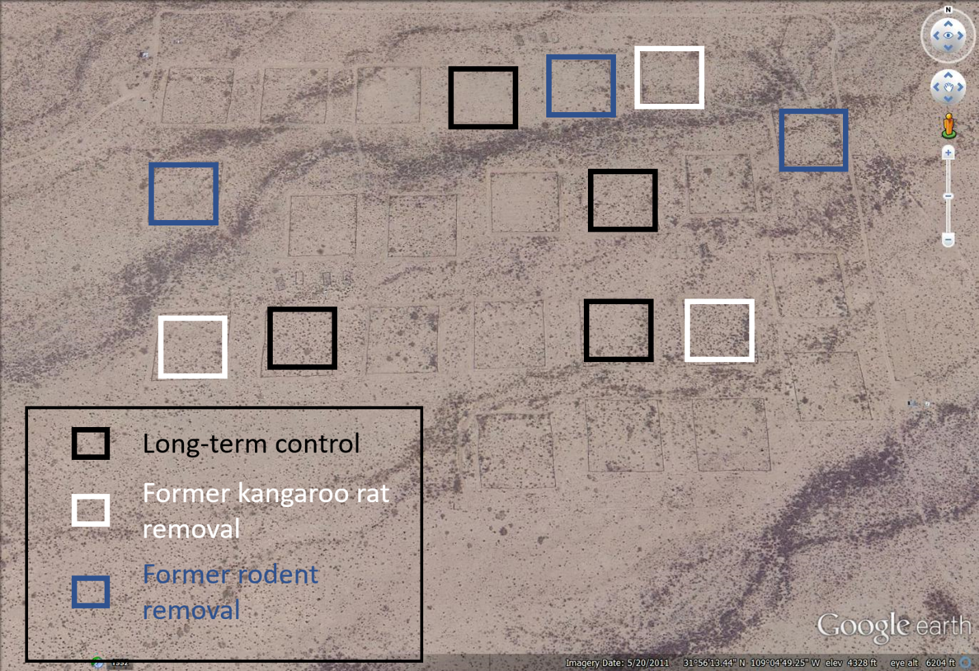

Figure 3-1. Map of the study area showing 10 experimental plots used for these analyses. The outlines of 14 additional plots not used for these analyses, but which are subject to similar experimental manipulations, can be faintly seen.

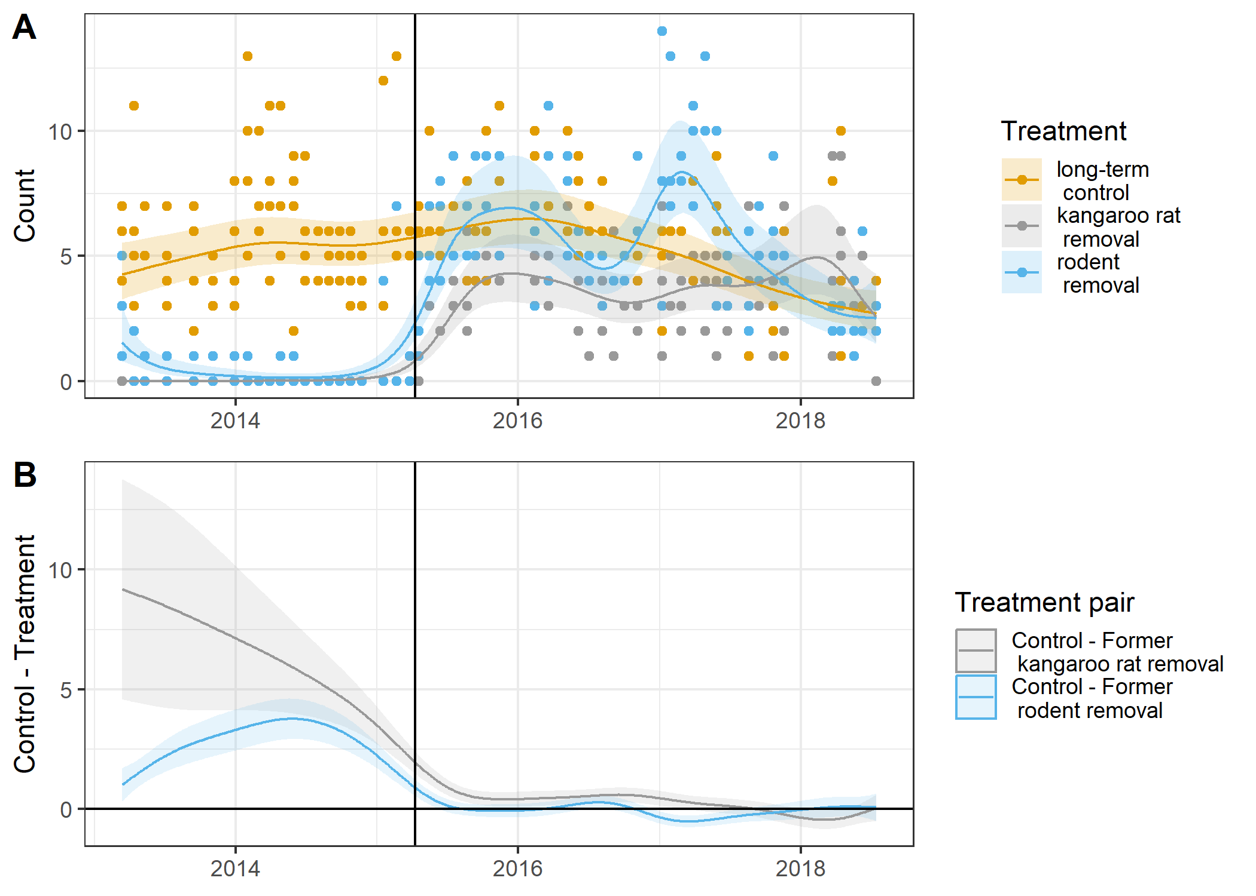

Figure 3-2. GAM model of number of kangaroo rats per plot. A) GAM model of number of kangaroo rats per plot and B) difference of treatment-specific smooths from GAM

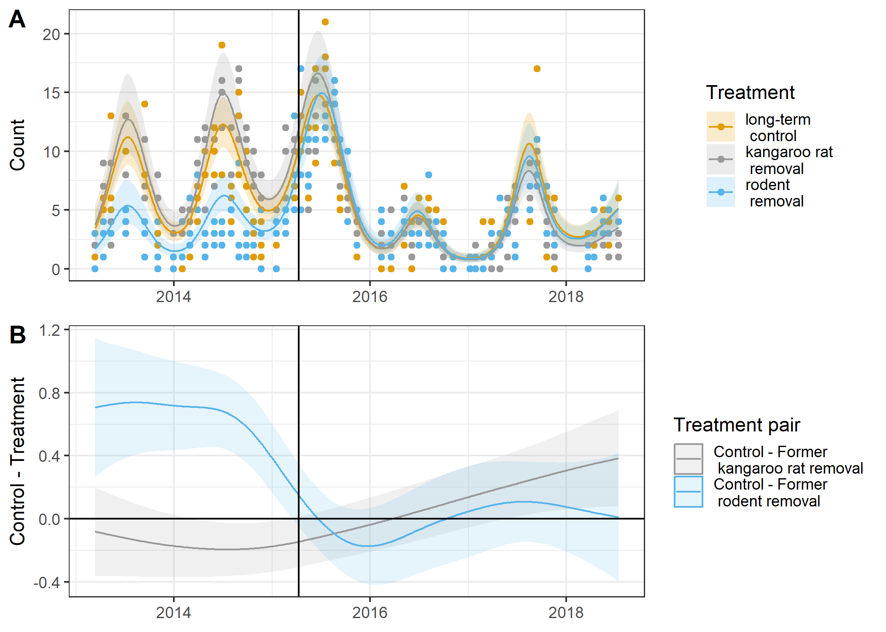

Figure 3-3. GAM model of abundances of non-kangaroo rat species per plot. A) GAM model of abundances of non-kangaroo rat species per plot and B) difference of treatment-specific smooths from GAM

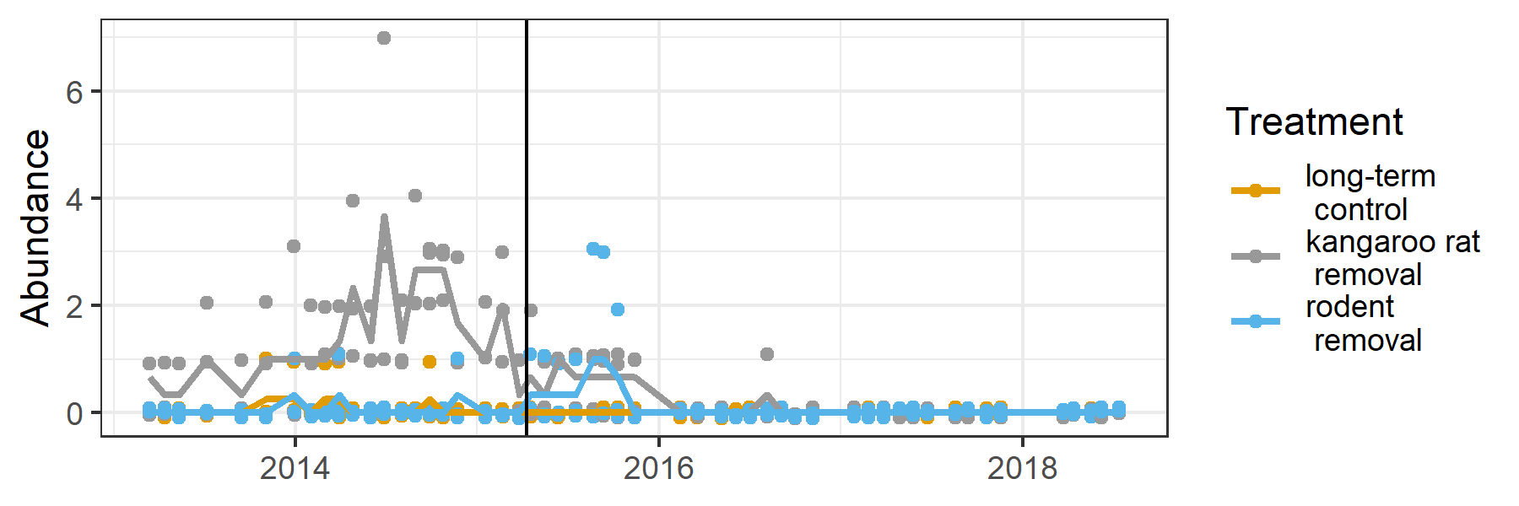

Figure 3-4. Populations of Bailey’s pocket mouse on experimental plots. Solid lines are average by treatment and month. Vertical line is when treatments were changed in March 2015.

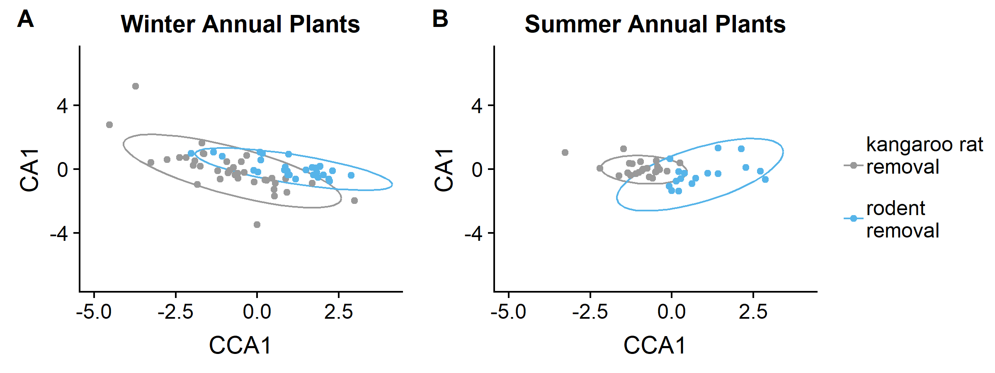

Figure 3-5. Comparison of annual plant communities on different treatments. pCCA of treatment effects on plant composition for A) winter and B) summer annual plants

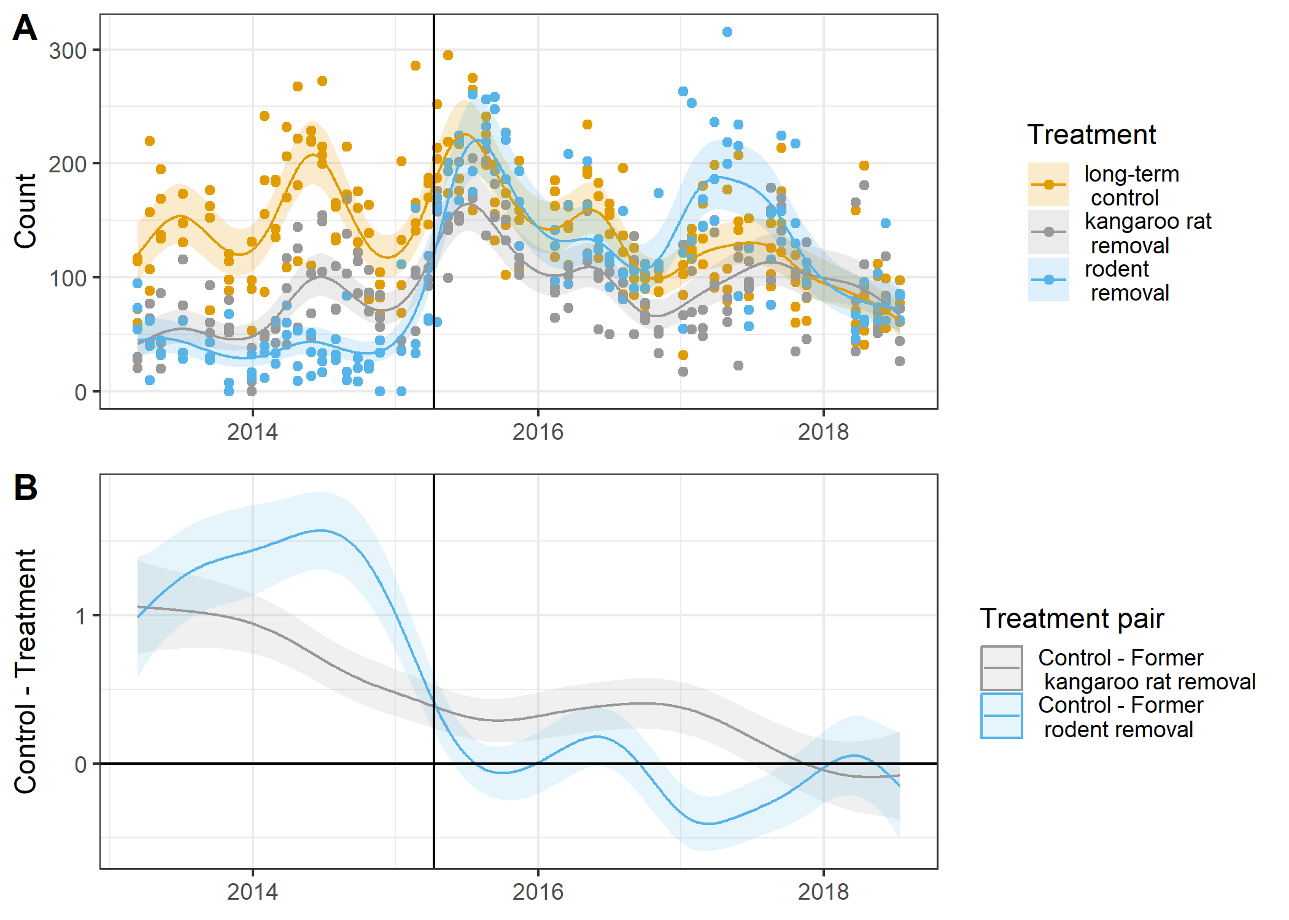

Figure 3-6. GAM model of community-level metabolic flux per plot. A) Community-level metabolic flux on control plots, kangaroo rat removal and rodent removal plots before and after treatments were converted to controls (vertical black line). B) GAM model differences between controls and former rodent removals, and controls and former kangaroo rat removals.

CHAPTER 4

SPECIES COMPOSITION MEDIATES RESPONSE OF A DESERT RODENT COMMUNITY TO EXTREME CLIMATE EVENTS

Introduction

Extreme climate events can cause long-lasting changes in the biodiversity of an ecosystem, both directly by acting on the population parameters of component species (e.g., direct mortality or suppressed reproduction), and indirectly by altering habitat (Smith 2011, Jiguet et al. 2011). Direct effects of disturbance such as increased mortality can act as a catalyst for change by removing inertia in the system (e.g., long-lived or territorial species), thereby setting the stage for the community to reassemble in a different configuration (Thibault and Brown 2008, Turner 2010). Indirect effects are expected when a disturbance alters some aspect of the habitat that in turn affects species’ fitness. Different species responses to habitat change may result in changes in species’ relative abundances or even species extinctions, though these effects may be time-lagged (Kuussaari et al. 2009, Jiguet et al. 2011). With climate models predicting more climate extremes in the future, a better understanding of reorganization events caused by extreme climate is critical.

Studying ecological reorganization in response to extreme climate events is complicated by the fact that while extreme events can trigger community change (Ciais et al. 2005, Albright et al. 2010, Wernberg et al. 2013), not every extreme event causes persistent changes in species composition. Whether naturally occurring or experimentally induced, it is clear that more than just the occurrence of an extreme climate event is required (Jentsch et al. 2011, Smith 2011). Why some extreme climate events cause communities to reorganize while others do not likely depends in part on differences between events in the timing, duration, frequency, and magnitude of the event (Boeck et al. 2011, Smith 2011). However, the abiotic characteristics of a climate event are likely only part of the equation. Numerous studies have shown that the resilience of a community of species (i.e., the ability to return to the pre-disturbance state) is strongly influenced by the structure and composition of the community (Morin et al. 2014, Oliver et al. 2015). Thus the state of the community when an extreme event occurs likely also determines whether that extreme event will also cause a reorganization event.

The structure and dynamics of communities are often strongly influenced by particular species within the community, thus these key species may play an important role in the response of a community to an extreme climate event. These key species may drive community dynamics through strong interactions with the rest of the species in the community (Paine 1995, Herren and McMahon 2018), or may simply be numerically dominant in the system (Arnone et al. 2011). Particularly when a community is strongly dominated by a single species, the resilience of the community as a whole in response to disturbance tends to be highly correlated to the resilience of this dominant species (Hillebrand et al. 2008). Therefore, whether or not a community responds to a particular disturbance may depend on the identity of species present in the system (e.g., ecosystem engineers, keystone taxa, dominant species) and their particular response to the event. Identifying when key species are unique determinants of community change, as opposed to when change is robust to details of species composition, is an important component to understanding when extreme events should be expected to result in community-level change.

Here, we use a 38-year experimental manipulation of a desert rodent community to ask how the removal of a group of key species – kangaroo rats (*Dipodomys* spp.) -- affects community response to naturally-occurring climate events. Kangaroo rats are highly influential members of desert rodent communities in the Southwest US, influencing other species both directly through competitive interactions (Valone and Brown 1995), and indirectly through impacts on vegetation and habitat structure (Brown and Heske 1990). Kangaroo rats are also frequently numerically dominant in this community, and their removal results in significant changes in the rodent community on plots where they are removed (Valone and Brown 1995). Previous studies, focused on plots where kangaroo rats had not been manipulated, documented several reorganization events in the rodent community associated with droughts and floods (Valone and Brown 1995, Thibault and Brown 2008, Christensen et al. 2018). The experimental manipulation of kangaroo rats gives us the unique opportunity to assess the role of species composition in influencing response to climate events by comparing dynamics in the rodent community with and without kangaroo rats in response to variation in the same climate conditions. If the composition of the community determines the sensitivity of the community to these climate events, then we should see differences in the presence of reorganization events between plots with and without kangaroo rats. However, if species composition plays little role in whether a climate event causes a reorganization event, then the dynamics on plots with and without kangaroo rats should be synchronous.

Methods

Data were from the Portal Project, a long-term study located on 20 ha of Chihuahuan Desert in southeastern Arizona. The study consists of 24 permanent 50 x 50 m plots, enclosed by 50 cm high hardware cloth fences with gates of varying size at ground level to control rodent access. Experimental plots contained small gates (1.9 x 1.9 cm) which allowed access to all species of rodent except *Dipodomys* which have particularly large skulls. Control plots contained large gates (3.7 x 5.7 cm) which allowed access to all species. The rodent community was sampled nearly every month from 1977 to 2015 by trapping each plot with 49 Sherman traps. If a kangaroo rat was trapped on an experimental kangaroo rat removal plot, its presence was recorded but it was removed from the plot. We restricted analysis to plots on which treatment was unchanged for the period 1977-2015 (4 experimental plots and 8 control plots). Because non-granivorous species of rodent represent a small proportion of the overall community and do not tend to be affected by the experimental removal of kangaroo rats (Valone and Brown 1995), we excluded these species from analysis in order to emphasize dynamics of the closely-competing granivorous species. We pooled data by plot treatment and time step, resulting in separate tables of species by time for each community (15 species and 436 time steps).

Following Christensen et al. 2018, we used a two-step approach to quantify dynamics of species composition of each of the two communities separately. First we reduced the dimensionality of the species composition data using Latent Dirichlet Allocation (LDA) (Blei et al. 2003). We then examined time series dynamics using a change-point model (Western and Kleykamp 2004), to locate points in time when each of the two communities demonstrated the largest amount of change. Finally, we compared the change-points of the experimentally altered community to the change-points of the control community. Code for this analysis is available on GitHub (https://github.com/weecology/LDA-kratplots).

Latent Dirichlet Allocation (LDA)

Latent Dirichlet Allocation is a machine-learning approach used in ecology to reduce the multi-dimensionality of species composition data in order to identify patterns of species associations and describe change in species composition across spatial or temporal gradients (Valle et al. 2014, Christensen et al. 2018). With a species by time matrix as input to the model, LDA identifies groups of species that were found together in particular proportions (hereafter referred to as community-types), and describes each sampling time point in terms of these community-types (essentially returning a time series of community-type composition, as opposed to the original species composition). We implemented this method similarly to the implementation described in Christensen et al. 2018, using the topicmodels package (version 0.2-7; Hornik and Grün 2011) for R 3.5.0 (R Core Team 2018). To streamline this approach, we developed an R package containing functions for running the LDA models, performing model selection, and running the change-point models (available on GitHub https://github.com/weecology/LDATS). The only major update from the implementation in Christensen et al 2018 was in the AIC model selection procedure used to select the appropriate number of community-types in the LDA model. The discrepancy lies with the counting of the parameters controlling the document-topic distribution. Whereas the previous method penalized for all of the variational parameters (gamma), the new method (following the approach of the topicmodels package and standards for variational methods; Blei et al. 2003, Hornik and Grün 2011) only penalizes for the hyper parameter (alpha) controlling the variational distribution.

Change-point Model

We used a change-point model to identify abrupt transitions in the time series of community types generated by the LDA models. Change-point models break up time series into sections with a different set of parameters to model the time series between each pair of change-points. We implemented a parallel tempering sampler with MCMC, and obtained posterior estimates of change-point locations. See Christensen et al. 2018 for a full description of the model and model selection procedures.

Comparison of Change-points

To compare the locations of change-points in the control community to change-points in the experimental community, we compared the overlap of the two distributions. This was computed by tallying the number of posterior estimates of change-point locations common to both communities (i.e., the area under both curves), and dividing by the total possible overlap.

Results

On the control plots, rodent community dynamics were best described with five community-types (Figure 4-1, A). This differs slightly from the four community-types presented in Christensen et al. 2018 because the previous work included folivorous and omnivorous species of rodents as well as granivorous (a difference of 6 species), and because of the improved method of calculating AIC for model selection. *Dipodomys* species are present in all five community-types and comprise greater than 50% of three of the community-types (community-types 1, 2, and 3).

As in the previous work, these results suggest that major shifts in community composition occurred at multiple points in time (Figure 4-1, B), and a change-point model including four change-points was best supported (Figure 4-1, C). The median dates obtained from the change-point location distributions (Figure 4-1, C) were: April 1984, April 1990, July 1999, and December 2009. These dates lined up with climate events noted in previous publications: a tropical storm in late 1983 (Valone et al. 1995), a localized drought that caused low plant abundances in 1990/1991 (Allington et al. 2013), a flood event in 1999 (Thibault and Brown 2008), and another drought in 2009 (Christensen et al. 2018). Many of these events appear to have strongly negatively impacted the rodent community, causing abnormally low rodent abundances (Christensen et al. 2018).

On plots where kangaroo rats had been removed, the rodent community was also best described using five community-types (Figure 4-2, A). In contrast to the community-types describing the controls, three of these community-types were composed nearly 100% of a single species, though which species is different between the three (community-types 2, 4, and 5). This suggests that either the community was highly dominated by each of these species (low evenness) at certain points in time, or the associations between these species and others were sufficiently different at different points in the time series that the LDA model was unable to detect any consistent patterns of association.

Figure 4-2, B shows the community-type composition time series. Visual inspection suggests that there is a great deal of variation in this composition early in the time series, but in the late 1990s community-type 4 became the dominant community-type. In 2010 community-type 4 gave way to community-type 5 and a strong seasonal oscillation began. Our change-point analysis of the community-type time series found that two change-point was best supported by the data: June 1997 and January 2010 (Figure 4-2, C).

Figure 4-3 shows the four change-points that describe major changes in control community dynamics overlaid with the two change-points describing major changes in the community with kangaroo rats experimentally removed. The credible intervals on the three earliest control community change-points and the earlier of the two experimental community change-points do not overlap with each other (control community change-point intervals: November 1983-March 1985; January 1990-April 1992; December 1998-November 1999; experimental community change-point intervals: December 1996-September 1997). However both communities had a change-point in late 2009/early 2010: in the control community this fell in December 2009 with a credible interval of May 2009-January 2011, and in the experimental community it fell in January 2010 with a credible interval of August 2009-July 2010. The overlap of the posterior estimates of these change-point locations was 75%.

Discussion

Our manipulations of species composition on plots demonstrates that differences in composition impacted the occurrence of reorganization events in response to climate events. Three of the four reorganization events on control plots either did not occur on plots lacking kangaroo rats or occurred more than a year apart in time (Figure 4-3). The exception to this is the change-point in early 2010 that occurred on both sets of plots at approximately the same time. Because our plots were interspersed within a relatively small spatial area (~20 hectares), climate events that impacted one plot type impacted all plot types. Therefore differences in the occurrence of reorganization events between plot types was not due to differences in climatic drivers. Instead, there was something about the differences in the species composition between these plots that determined when reorganization events would occur.

One obvious way that differences in species composition would cause communities to respond differently to the same climate dynamics would be if the two communities had little or no overlap in their component species. Two communities comprised of species with non-overlapping niches might result in one community responding extremely negatively to a climate event while the other community was very resistant (e.g., differences in drought resistance or fire adaptation (Hoffmann et al. 2003, O’Brien et al. 2014)). While our manipulation did result in different community compositions, there was still nearly complete overlap in species presence on our control and kangaroo rat removal plots (the only exception is that the largest kangaroo rat, *Dipodomys* *spectabilis*, was never observed on kangaroo rat removal plots; Figure 4-1, A and Figure 4-2, A). The main difference between these communities was in the structure of the community – the population size of each species and which species were the most abundant. This suggests that there was something about the structure of the community—either in the identity of the dominant species or in the network of interactions among species—that influenced whether climate events also caused these communities to reorganize.

Three of our climate-associated reorganization events on control plots appear to be driven by rapid declines in one of the abundant species in the community that then provided opportunities for other species. The 1984 change-point observed in the control community was related to the rapid decline of a single species of kangaroo rat (*D.* *spectabilis*) in response to heavier than usual rains from tropical storm Octave in the previous season (Valone et al. 1995). The shift at this time from community-type 1 (which is co-dominated by *D. spectabilis* and *D. merriami*) to community-type 2 (which is dominated by *D. merriami* alone; Figure 4-1, A-B) occurred in part from the decline in *D. spectabilis* and another species, *Perognathus flavus*, and in part from increases in several other species (Valone et al. 1995). However, the lack of a turnover event on the kangaroo rat removal plots indicates that in the absence of kangaroo rats, this climate event had little impact on community structure. This suggests that it was the susceptibility of the kangaroo rats – specifically *D. spectabilis* – to this specific rainfall event that provided new opportunities to other species in the community, resulting in a substantive change in community structure.

Like the 1984 event, the 1999 event on the control plots seems likewise to result from a strong negative response by a dominant species to a climate event that resulted in opportunities for other species in the community. In the summer of 1999 a sheet flood caused high mortality of kangaroo rat species. Before this event, the community was dominated by kangaroo rats (i.e. community-type 3; Figure 4-1, B) but after this event, the community became dominated by two species of pocket mice (*Chaetodipus baileyi* and *C. penicillatus*, community-types 4 and 5, respectively in Figure 4-1) (Thibault and Brown 2008). While *C. penicillatus* had been present at the site since the beginning of the study, *C. baileyi* colonized the site for the first time in 1995 (Ernest and Brown 2001). However it did not become an abundant species on control plots until the flood of 1999 (Thibault and Brown 2008). The negative response of the kangaroo rats to the flood event may have given *C. baileyi* an opportunity for population growth that did not previously exist (Thibault and Brown 2008). This interpretation is supported by dynamics on the kangaroo rat removal plots. The reorganization event on the kangaroo rat removals, involving the increase in *C. baileyi* from a rare species to a dominant one, occurred approximately two years earlier (Figures 4-2 and 4-3). Thus, on plots without kangaroo rats, *C. baileyi* was able to easily invade and establish dominance, but on control plots it was only able to do this when a natural event removed kangaroo rats temporarily, providing a window of opportunity.

The 2010 event also supports the idea that a strong negative impact of a climate event on the dominant species is linked with reorganization events. In this event, the control community shifted from one where *C. baileyi* was a dominant or co-dominant species in the system to one where dominance oscillates seasonally between the kangaroo rats and *C. penicillatus* (Figure 4-1). *C. baileyi* is known to be a drought-intolerant species (Linzey et al 2016; Wilson and Ruff 1999) and a drought at the site is a likely contributor to its population crash. This was the only climate event that resulted in concurrent reorganizations on both types of plots (Figure 4-3). Unlike all other reorganization events, this was the only event when control plots and kangaroo rat removal plots shared a dominant species that responded negatively to the climate event: *C. baileyi*. Because *C. baileyi* was a dominant species on both plot types, its population decline associated with the drought of 2009/2010 provided similar opportunities for other species on both types of plots, thus generating concurrent reorganization events.

While three of the reorganization events on the control plots seem to result from the opportunities generated for other species by the negative impacts of a climate event on the dominant species, the 1990 event appears to be different. In 1990, the rodent community on the control plots changed from community-type 2 to community-type 3 (Figure 4-1). Unlike the other events, there was no change in the dominant species associated with this event: *D. merriami* is dominant in both community-types. Instead, the two community-types differ the degree of dominance of *D. merriami* in the community (this species comprises approximately 57% of community-type 2 and 86% of community-type 3; Figure 4-1, A). This was not the result of a significant increase in *D. merriami* populations at this time, but rather a decrease in populations of sub-dominant species while numbers of *D. merriami* remained constant (See Appendix D: Figure D-1, A). These sub-dominant species were also present on kangaroo rat removal plots where some species also experienced population declines (Figure D-1, B): however as kangaroo rats were not present, and there was no analogous species whose population remained constant, there was no clear change in the relative abundances of species. As our models are built to identify changes in relative abundances of species, they did not identify this as a change-point on kangaroo rat removal plots. We do not currently understand the mechanisms underlying this change-point, but our best hypothesis is that this change-point is related to processes that shifted the dominance of the kangaroo rat species, *D. merriami*, and how it was impacting other species on control plots. Kangaroo rats impact other species through direct aggression (Falkenberg and Clarke 1998), depletion of resources (Brown and Heske 1990), and other activities (e.g., impacts on the plant community, burrows; (Guo 1996)). It is unclear what aspect of kangaroo rat interactions with other species shifted in 1990, but unlike the other events, this event does not seem to be the result of a climate-induced population crash by the dominant that allowed another species to take over.

Our results clearly indicate that the composition of a community influences the occurrence of reorganization events. Often these events involve strong negative responses of a dominant species to the climate event. Removal of a strong competitor can create niche opportunities (Shea and Chesson 2002) and remove the incumbent advantage (Amarasekare 2002, Thibault and Brown 2008). This could promote reorganization events through stochastic processes, such as priority effects (Fukami 2015), as new individuals disperse into the community to take the place of deceased individuals of the prior dominant species. It could also promote reorganization events through more deterministic processes. Incumbent advantages can slow invasion dynamics and community change, even when the incumbent is competitively inferior to other species (Amarasekare 2002). Thus by removing the numerical advantage of a sub-optimal dominant species, climate events may accelerate ongoing change by allowing better competitors that are more suited to the local environment become established. Without a strong negative population response by the dominant species, however, large establishment opportunities, through stochastic or deterministic processes, do not exist or are much smaller (i.e., compared to a scenario where only rare species are negatively impacted). Thus, we may expect that an extreme climate event only causes community reorganization if the dominant species in the system is susceptible to that disturbance.

While events related to negative impacts on populations of dominant species is the most common type of reorganization event in our data, we also saw an example of a different type that may be due to changes in species interactions. Competitive interactions between species are subject to change through time, affected by changes in resource availability (Chesson 1994) and changes in abiotic conditions (Tylianakis et al. 2008, Gilman et al. 2010). An extreme climate event may shift the advantage to species that are able to tolerate the disturbance, rather than species with highest competitive ability. Alternatively, in times of resource scarcity, competitive differences between species may be even more pronounced, compounding negative effects on less-adept competitors. In our system, changes in rainfall patterns in the early 1990s led to a reduction of seed resources available to rodents (Allington et al. 2013). Although both control plots and kangaroo rat removal plots would have experienced this resource change, sub-dominant species on control plots had the added stressor of the presence of competitively-dominant kangaroo rats. It’s possible that the compounded pressures of low resources and strong competition from kangaroo rats are responsible for reduced populations of sub-dominant competitors on control plots, resulting in the 1990 shift to a community highly dominated by a single species.

While the characteristics of extreme climate events – their magnitude, timing, and duration – are undoubtedly important for predicting whether a particular event will cause reorganizations in biodiversity, our results suggest that this information will not be enough in isolation to predict when reorganizations will occur. Predicting biodiversity responses to climate events will require understanding them in the context of the species experiencing the climate events. Unfortunately, making these assessments for all of the species in a community may be daunting, or even impossible for extremely speciose or understudied ecosystems. Our results suggest that we may be able to make progress by focusing on key species within a community, either the most abundant species or keystone species with unique and important roles in structuring the network of interactions within an ecosystem. By focusing our efforts on these species, we may be able to provide general expectations for what types of events are most likely to create scenarios where rapid reorganization events may occur.



Figure 4-1. Results of LDA analysis on rodent community on control plots. A) species composition of the five community-types produced by the LDA model; B) time series of community-type composition of samples over time, described by the five community-types from A; C) histograms of four change-points representing the greatest changes in community-type composition from B. Species codes in panel A: DS = *Dipodomys* *spectabilis*, DO = *Dipodomys* *ordii*, DM = *Dipodomys* *merriami*, CB = *Chaetodipus* *baileyi*, CH = *Chaetodipus* *hispidus*, PL = *Peromyscus* *leucopus*, PM = *Peromyscus* *maniculatus*, PE = *Peromyscus* *eremicus*, CP = *Chaetodipus* *penicillatus*, CI = *Chaetodipus* *intermedius*, RF = *Reithrodontomys* *fulvescens*, RM = *Reithrodontomys* *megalotis*, RO = *Reithrodontomys* *montanus*, BA = *Baiomys* *taylori*, PF = *Perognathus* *flavus*



Figure 4-2. Results of LDA analysis on community with kangaroo rats experimentally removed. A) species composition of the five community-types produced by the LDA model; B) time series of community-type composition of samples over time, described by the five community-types from A; C) histograms of four change-points representing the greatest changes in community-type composition from B. Species codes in panel A: DS = *Dipodomys* *spectabilis*, DO = *Dipodomys* *ordii*, DM = *Dipodomys* *merriami*, CB = *Chaetodipus* *baileyi*, CH = *Chaetodipus* *hispidus*, PL = *Peromyscus* *leucopus*, PM = *Peromyscus* *maniculatus*, PE = *Peromyscus* *eremicus*, CP = *Chaetodipus* *penicillatus*, CI = *Chaetodipus* *intermedius*, RF = *Reithrodontomys* *fulvescens*, RM = *Reithrodontomys* *megalotis*, RO = *Reithrodontomys* *montanus*, BA = *Baiomys* *taylori*, PF = *Perognathus* *flavus*



Figure 4-3. Comparison of change-points from control community (gray) to change-points from experimentally altered community (red).



Figure 4-4. Populations of *Chaetodipus baileyi* on control plots (black) and kangaroo rat removal plots (red). Vertical lines show locations of change-points: July 1999 and December 2009 on controls, June 1997 and January 2010 on kangaroo rat removals.

CHAPTER 5

CONCLUSIONS

The main goal of this research was to examine the patterns and processes of community change through time. Theory gives us many predictions of how change might be happening, but it is often difficult to distinguish between competing mechanisms in observed community data.

The goal of Chapter 2 was to identify patterns of change in a desert rodent community over a 38-year period and to connect these patterns to potential drivers of change. I used Latent Dirichlet Allocation (LDA) and a change-point model to examine the long-term dynamics of the community undergoing compositional change. This approach detected three rapid reorganization events, where changes in the relative abundances of dominant and rare species occurred, and a separate period of increased variance in the structure of the community. These events coincided with time periods—possibly related to climate events—where the total abundance of rodents was extremely low. There are a variety of processes that could link low abundance events with a higher probability of rapid ecological transitions, including higher importance of stochastic processes (i.e., competitive interactions or priority effects) and the removal of structuring effects of competitive dominants or incumbent species. While this approach could not determine the exact processes driving change in this community, the results indicate that much of the change occurred in short bursts, interspersed by periods of relative stability. Identifying broad patterns of change is an important first step toward understanding the processes structuring communities and will provide guidance for forecasting how communities will undergo change in the future.

Equally important to understanding what processes drive change is understanding the processes that may impede change. For example, theory predicts that established species can impede shifts in species composition via a variety of mechanisms, including direct interference (e.g. territoriality), preempting resources, or habitat alteration. In Chapter 3, I used an experimental manipulation to test for the presence of such “incumbency effects.” Specifically, I tested whether an established community impedes colonization by species which would otherwise be successful competitors. I found that dominant competitors in the community (kangaroo rats of the genus Dipodomys) were less successful in colonizing plots where there was an established community of other rodent species in place compared to empty plots. While all experimental plots eventually converged to controls, this process took approximately two years on plots with a previously-established community, compared to three months on empty plots. I found little evidence that the delay in kangaroo rat colonization was due to direct interference from competitors, or could be explained by differences in habitat, implicating resource preemption by the established community as the most likely mechanism. These results demonstrate that the presence of an established alternate community inhibits recolonization by new species, even species that should be dominant in the community. This has important implications for understanding how biodiversity may change in the future and what processes may slow or prevent this change.

In Chapter 4, I expanded on the results of Chapter 2 by asking what role species interactions played in driving patterns of community change. I analyzed observations from two rodent communities over a 38-year span: one community which had been manipulated to remove a key group of species (kangaroo rats of the genus *Dipodomys* are competitively and numerically dominant in desert rodent systems), and one community which was left unmanipulated. Though both communities experienced the same abiotic drivers, including extreme weather events, the effects of the events on the community as a whole were often different between the two communities. Predicting biodiversity responses to climate events will require understanding them in the context of the species experiencing the climate events .

That ecosystems have been changing all over the globe, and will likely continue to change, is not disputed. Disentangling the attributes or processes that cause change, and conversely those that contribute to stability or resilience, is an important area of research from many different perspectives. In these projects I analyzed a rodent dataset of unusual size and concluded that most change in species composition and community structure over a 38-year period occurred in discrete events interspersed by periods of relative stability; that an established community of sub-dominant species was able to partially inhibit colonization by a dominant competitor; and that species interactions were important in controlling whole-community response to disturbance. Though more work is necessary to determine if these conclusions hold generally or are specific to this desert rodent system, this research demonstrates the value of long-term observational studies, as well as several new analytical techniques, for understanding how communities have changed in the past and will change in the future.

APPENDIX A

SUPPLEMENTARY EXPLANATION OF LDA METHODS, AND DEMONSTRATION USING SIMULATED DATA SET

LDA is easiest to understand as a generative model, moving from the top of Figure A-1 to the bottom. LDA postulates that species assemblages are composed of random samples from a relatively small number of community-types, which are defined in terms of relative species composition (Figure A-1, A). In this context, community-types (referred to as “topics” in most of the LDA literature), could represent guilds, clades, or other groups of species whose abundances tend to rise and fall together. Assemblages (Figure A-1, C) are generated by randomly drawing species from each of these community-types, with the relative frequency of each community-type determined by the proportions in Figure A-1, B.

Fitting an LDA model thus involves simultaneously determining two sets of numbers: one defining the community-types (Figure A-1, A), and one describing the observed species assemblages in terms of those types (Figure A-1, B). This requires working backwards from observed patterns to infer the parameters of a possible underlying process – i.e., moving in Figure A-1 from panel D up to panels A and B.

We simulated the simple scenario of two community-types containing overlapping sets of species, but with different permutations of species’ relative abundances (Figure A-2, A). Using these two community-types, we simulated five different speeds of dynamics: a fast transition (occurring over 12 monthly time steps, or one year) from one community-type to the other (Figure A-2, B), a transition occurring over 2 years (Figure A-2, C), a transition occurring over 5 years (Figure A-2, D), a transition occurring over 25 years (Figure A-2, E), and no transition (i.e. constant proportions of the two community-types over time; Figure A-2, F). Applied to the simulated data, the LDA model reproduced the composition of the two simulated community-types (Figure A-2, G-J) and the dynamics (Figure A-2, L-O) of all four scenarios containing a transition. The model failed to reproduce the simulated data when the two community-types were represented by constant proportions over time (Figure A-2, K, P). This illustrates a limitation of this approach: if there is no change in dominance from one community-type to another (i.e. “stable” community configuration over time), the algorithm will have difficulty distinguishing the two community-types.

When change is fast (i.e. occurs over a small number of time steps), the change point model identifies a narrow range of times as the likely location of the shift from one community type to another (Figure A-2, Q). When change is slow (i.e. occurs gradually over a large number of time steps), it is less certain where this shift occurs and the distribution of change-point locations is wider (Figure A-2, T). A uniform distribution emerged when no change occurred (Figure A-2, U).



Figure A-1. Graphical representation of the LDA model. A) Community-type definitions: the relative species composition of each community-type; B) Community-type proportions: the relative frequency of each community-type contributing to assemblages; C) Assemblages: generated by randomly drawing species from the community-type pools in A according to the proportions in B; D) Species composition of assemblages, as would be seen in actual community data.



Figure A-2. Demonstrating LDA and change-point model using simulated data. A) species composition of two community-types to be simulated; B) simulation of rapid transition (duration of one year) from community-type 1 to community-type 2; C) simulation of transition lasting 2 years; D) simulation of transition lasting 5 years; E) simulation of transition lasting 25 years; F) simulation of unchanging community dynamics; G-K) species composition of two community-types as output from the LDA model; L-P) output of LDA model, aiming to recover dynamics simulated in panel B-F; Q-U) histograms showing the distribution of estimated change-point location.

APPENDIX B

SUPPLEMENTAL FIGURES AND TABLES FOR CHAPTER 2

Table B-1. Species relative abundances in the four community-types estimated by the LDA model. Species codes: NA = *Neotoma albigula*, DS = *Dipodomys spectabilis*, SH = *Sigmodon hispidus*, SF = *Sigmodon fulviventer*, SO = *Sigmodon ochrognathus*, DO = *Dipodomys ordii*, DM = *Dipodomys merriami*, CB = *Chaetodipus baileyi*, CH = *Chaetodipus hispidus*, OL = *Onychomys leucogaster*, OT = *Onychomys torridus*, PL = *Peromyscus leucopus*, PM = *Peromyscus maniculatus*, PE = *Peromyscus eremicus*, CP = *Chaetodipus penicillatus*, CI = *Chaetodipus intermedius*, RF = *Reithrodontomys fulvescens*, RM = *Reithrodontomys megalotis*, RO = *Reithrodontomys montanus*, BA = *Baiomys taylori*, PF = *Perognathus flavus*.

|  |  |  |  |  |
| --- | --- | --- | --- | --- |
|  | | | | |
| Species | Community-type 1 | Community-type 2 | Community-type 3 | Community-type 4 |
| NA | 0.088 | 0.025 | 0.024 | 0.001 |
| DS | 0.340 | 0.000 | 0.000 | 0.000 |
| SH | 0.001 | 0.004 | 0.020 | 0.000 |
| SF | 0.000 | 0.003 | 0.014 | 0.000 |
| SO | 0.000 | 0.001 | 0.000 | 0.000 |
| DO | 0.076 | 0.128 | 0.211 | 0.018 |
| DM | 0.341 | 0.606 | 0.078 | 0.216 |
| CB | 0.000 | 0.000 | 0.450 | 0.025 |
| CH | 0.000 | 0.001 | 0.000 | 0.000 |
| OL | 0.061 | 0.030 | 0.003 | 0.001 |
| OT | 0.051 | 0.064 | 0.130 | 0.006 |
| PL | 0.000 | 0.000 | 0.004 | 0.000 |
| PM | 0.000 | 0.012 | 0.006 | 0.000 |
| PE | 0.011 | 0.041 | 0.016 | 0.000 |
| CP | 0.000 | 0.000 | 0.022 | 0.722 |
| CI | 0.000 | 0.000 | 0.006 | 0.002 |
| RF | 0.000 | 0.001 | 0.000 | 0.000 |
| RM | 0.000 | 0.049 | 0.000 | 0.000 |
| RO | 0.000 | 0.001 | 0.009 | 0.002 |
| BA | 0.000 | 0.001 | 0.009 | 0.002 |
| PF | 0.030 | 0.032 | 0.007 | 0.006 |



Figure B-1. We estimated model fit using an approximate AIC procedure, to compare LDA models using 2 to 9 community-types. Since LDA depends on a random seed, we repeated the LDA model fit and AIC model selection using 200 different seeds to obtain a distribution of “best number of community-types.” This procedure always selected between 3 and 5 community-types, with 4 selected by the majority of runs.



Figure B-2. Comparison of change-point models fit with 2, 3, 4, or 5 change-points. The model containing 4 change-points was best supported.



Figure B-3. Results of LDA model fit with three community-types.



Figure B-4. Results of LDA model fit with four community-types.



Figure B-5. Results of LDA model fit with five community-types.



Figure B-6. Normalized Difference Vegetation Index (NDVI) yearly average for 1984-2015. NDVI values were obtained from a combination of data from satellites Landsat 4, 5, 7, and 8. Raster NDVI files were downloaded from earthexplorer.usgs.gov and clipped to a 5 km2 area centered over the Portal Project site. We calculated median NDVI value for each 5 km2 image, and calculated correction factors based on the periods of overlap between satellites so data from all satellites could be directly compared. We calculated a time series of average yearly NDVI for each year for which there were at least 12 images spanning at least 6 months of the year

APPENDIX C

SUPPLEMENTAL FIGURES FOR CHAPTER 3

Additional Plant Community Comparisons

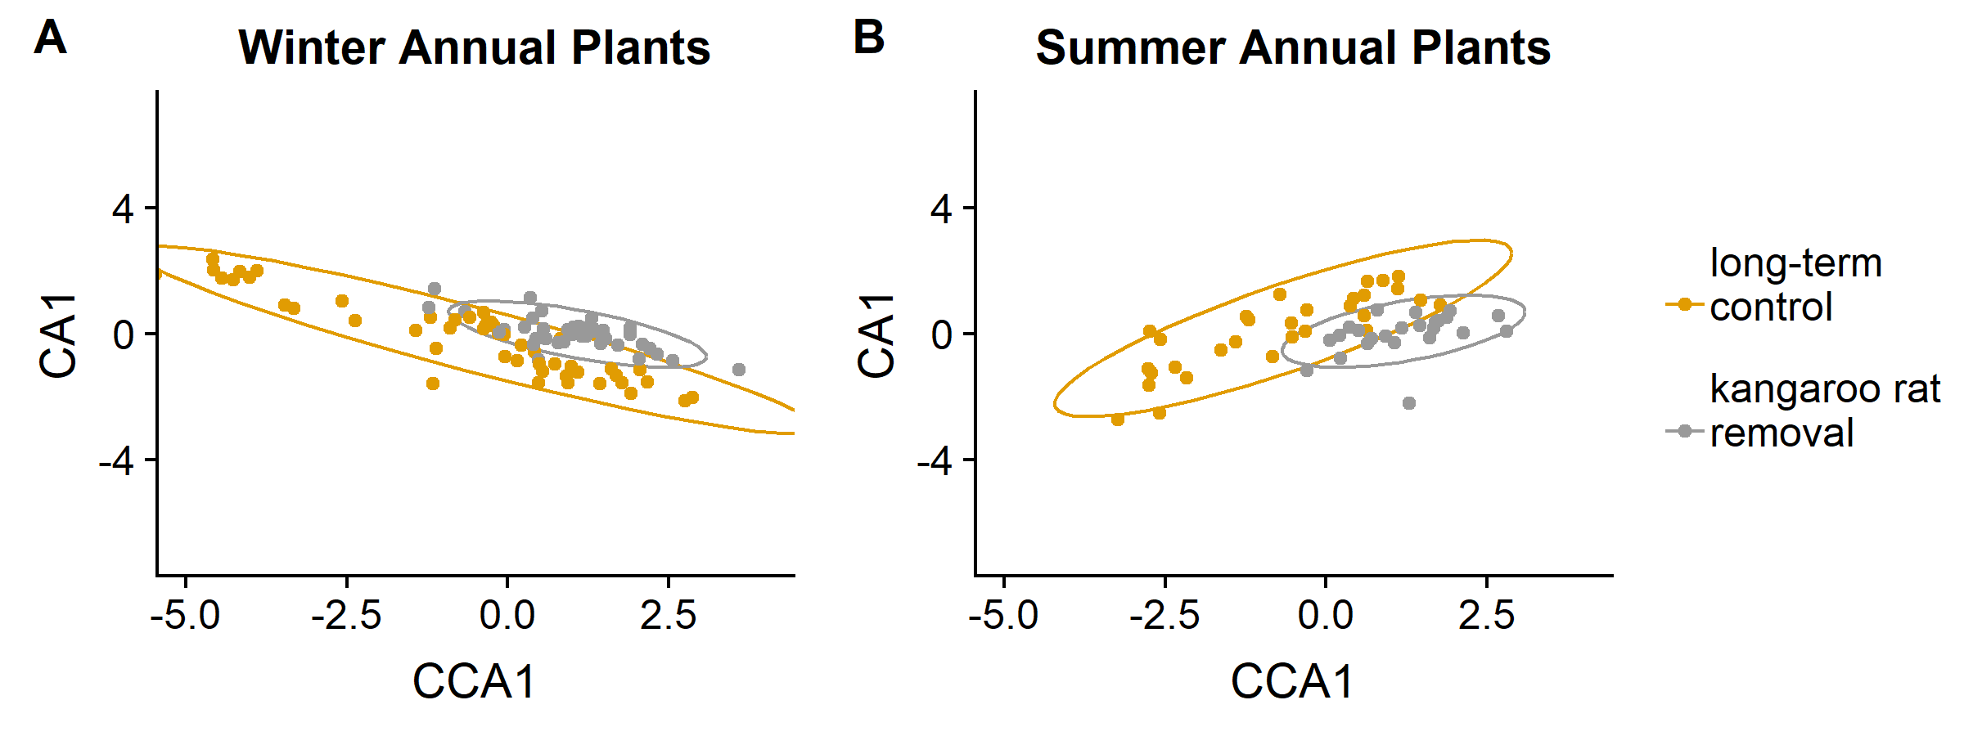

Figure C-1. Comparison of plant communities (summer and winter) on controls to plant communities on kangaroo rat removals before the treatment change in 2015.

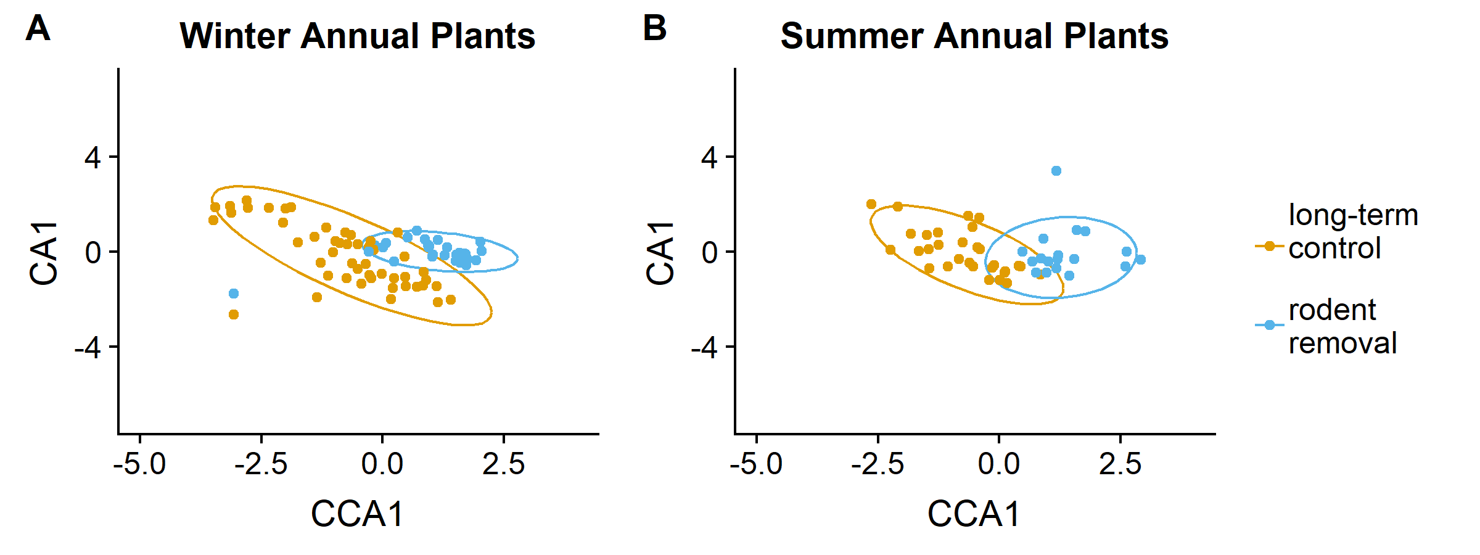

Figure C-2. Comparison of plant communities (summer and winter) on controls to plant communities on rodent removals before the treatment change in 2015.

Comparing Metrics Between Treatments Pre-flip

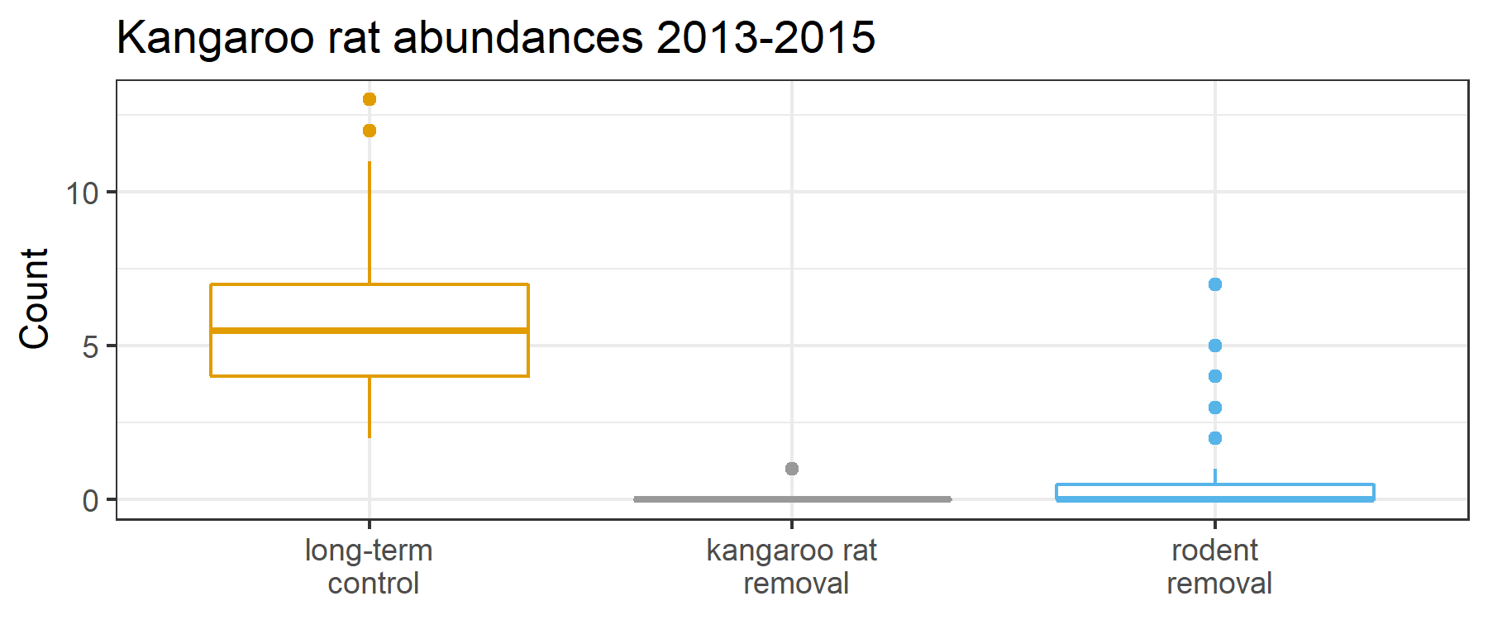

Figure C-3. Numbers of kangaroo rats were significantly different between treatments for the 2-year period before the treatment change (p<.0001) from a Kruskal-Wallis test.

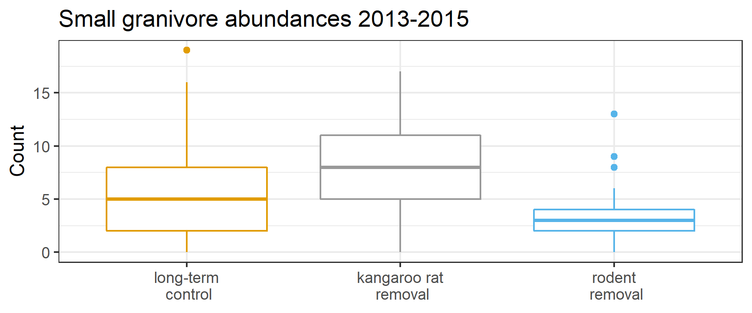

Figure C-4. Numbers of non-kangaroo rat individuals showed significant differences between treatments during the 2-year period before the treatment change, p<.0001 from a Kruskal-Wallis test.

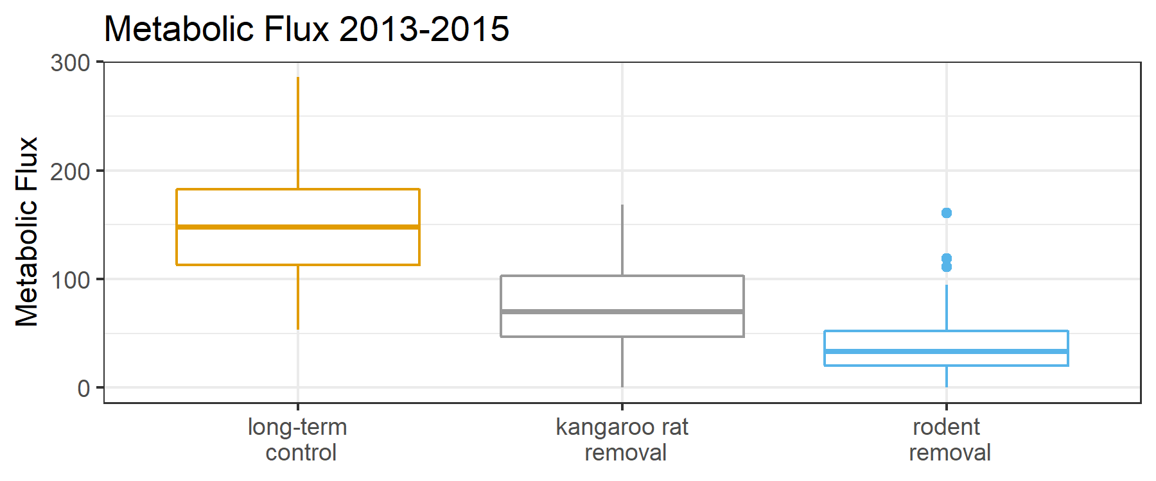

Figure C-5. Total metabolic flux showed significant differences for the 2-year period before the treatment change (p<.0001) from a Kruskal-Wallis test.

Appendix D

SUPPLEMENTAL FIGURES FOR CHAPTER 4

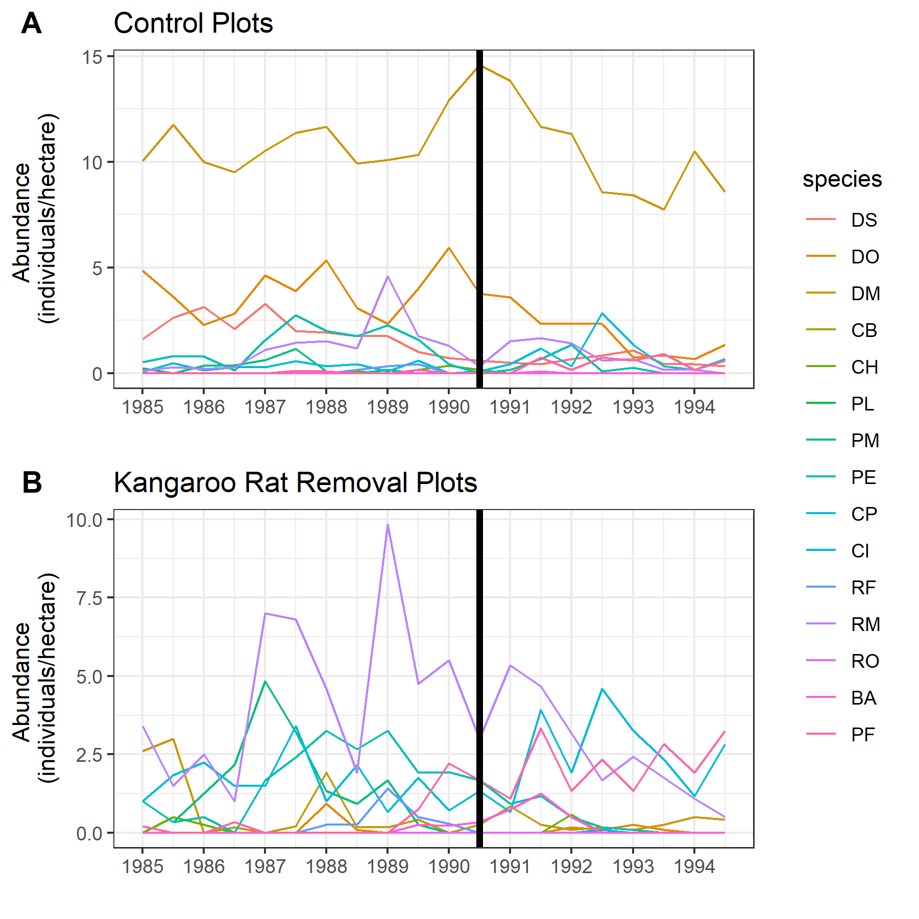

Figure D-1. Species population sizes around the observed change-point in April 1990 on control plots (A) and kangaroo rat removal plots (B). Values are 6-month averages of individuals per hectare. Two-letter species codes: DS = *Dipodomys* *spectabilis*, DO = *Dipodomys* *ordii*, DM = *Dipodomys* *merriami*, CB = *Chaetodipus* *baileyi*, CH = *Chaetodipus* *hispidus*, PL = *Peromyscus* *leucopus*, PM = *Peromyscus* *maniculatus*, PE = *Peromyscus* *eremicus*, CP = *Chaetodipus* *penicillatus*, CI = *Chaetodipus* *intermedius*, RF = *Reithrodontomys* *fulvescens*, RM = *Reithrodontomys* *megalotis*, RO = *Reithrodontomys* *montanus*, BA = *Baiomys* *taylori*, PF = *Perognathus* *flavus*

LIST OF REFERENCES

Albright, T. P., A. M. Pidgeon, C. D. Rittenhouse, M. K. Clayton, C. H. Flather, P. D. Culbert, B. D. Wardlow, and V. C. Radeloff. 2010. Effects of drought on avian community structure. Global Change Biology 16:2158–2170.

Allington, G.R.H., D.N. Koons, S.K.M. Ernest, M.R. Schutzenhofer, and T.J. Valone. 2013. Niche opportunities and invasion dynamics in a desert annual community. Ecology Letters 16:158–166.

Amarasekare, P. 2002. Interference competition and species coexistence. Proceedings of the Royal Society of London B: Biological Sciences 269:2541–2550.

Anderson, D.R., K.P. Burnham, and G.C. White. 1994. AIC Model Selection in Overdispersed Capture-Recapture Data. Ecology 75:1780-1793.

Arnone, J. A., R. L. Jasoni, A. J. Lucchesi, J. D. Larsen, E. A. Leger, R. A. Sherry, Y. Luo, D. S. Schimel, and P. S. J. Verburg. 2011. A climatically extreme year has large impacts on C4 species in tallgrass prairie ecosystems but only minor effects on species richness and other plant functional groups. Journal of Ecology 99:678–688.

Bagchi, S., N.J. Singh, D.D. Briske, B.T. Bestelmeyer, M.P. McClaran, and K. Murthy. 2017. Quantifying long-term plant community dynamics with movement models: implications for ecological resilience. Ecological Applications 27:1514-1528.

Beaugrand, G. 2004. The North Sea regime shift: Evidence, causes, mechanisms and consequences. Progress in Oceanography 60:245–262.

Beisner, B.E., D.T. Haydon, and K. Cuddington. 2003. Alternative Stable States in Ecology. Frontiers in Ecology and the Environment 1:376–382.

Blei, D.M., A.Y. Ng, and M.I. Jordan. 2003. Latent Dirichlet Allocation. Journal of Machine Learning Research 3:993–1022.

Brown, J. H. 1998. The desert granivory experiments at Portal. Pages 71-95 in W.J. Resetarits Jr. and J. Bernardo, editors. Experimental Ecology. Oxford University Press, New York, New York, USA.

Brown, J. H., and E. J. Heske. 1990. Control of a Desert-Grassland Transition by a Keystone Rodent Guild. Science 250:1705–1707.

Brown, J.H., J.F. Gillooly, A.P. Allen, V.M. Savage, and G.B. West. 2004. Toward a Metabolic Theory of Ecology. Ecology 85:1771–1789.

Brown, J.H., T.J. Valone, and C.G. Curtin. 1997. Reorganization of an arid ecosystem in response to recent climate change. Proceedings of the National Academy of Sciences 94:9729–9733.

Boeck, H. J. D., F. E. Dreesen, I. A. Janssens, and I. Nijs. 2011. Whole-system responses of experimental plant communities to climate extremes imposed in different seasons. New Phytologist 189:806–817.

Burkart, S., F. Gugerli, J. Senn, R. Kuehn, and J. Bolliger. 2016. Evaluating the functionality of expert-assessed wildlife corridors with genetic data from roe deer. Basic and Applied Ecology 17:52–60.

Chase, J.M., and M.A. Leibold. 2003. Ecological Niches: Linking Classical and Contemporary Approaches. University of Chicago Press, Chicago, IL.

Chesson, P. 1994. Multispecies Competition in Variable Environments. Theoretical Population Biology 45:227–276.

Chesson, P. 2000. Mechanisms of Maintenance of Species Diversity. Annual Review of Ecology and Systematics 31:343–366.

Christensen, E.M., D.J. Harris, and S.K.M. Ernest. 2018. Long‐term community change through multiple rapid transitions in a desert rodent community. Ecology 99:1523-1529.

Christensen, E.M., D.J. Harris, and S.K.M. Ernest. 2018. emchristensen/Extreme-events-LDA: First release (Version v1.0.0). Zenodo. <http://doi.org/10.5281/zenodo.1217619>

Ciais, P., M. Reichstein, N. Viovy, A. Granier, J. Ogée, V. Allard, M. Aubinet, N. Buchmann, C. Bernhofer, A. Carrara, F. Chevallier, N. De Noblet, A. D. Friend, P. Friedlingstein, T. Grünwald, B. Heinesch, P. Keronen, A. Knohl, G. Krinner, D. Loustau, G. Manca, G. Matteucci, F. Miglietta, J. M. Ourcival, D. Papale, K. Pilegaard, S. Rambal, G. Seufert, J. F. Soussana, M. J. Sanz, E. D. Schulze, T. Vesala, and R. Valentini. 2005. Europe-wide reduction in primary productivity caused by the heat and drought in 2003. Nature 437:529–533.

Corbin, J.D., and C.M. D’Antonio. 2004. Competition Between Native Perennial and Exotic Annual Grasses: Implications for an Historical Invasion. Ecology 85:1273–1283.

Davis, A.J., J.H. Lawton, B. Shorrocks, and L.S. Jenkinson. 1998. Individualistic Species Responses Invalidate Simple Physiological Models of Community Dynamics under Global Environmental Change. Journal of Animal Ecology 67:600–612.

Dornelas, M., N.J. Gotelli, B. McGill, H. Shimadzu, F. Moyes, C. Sievers, and A.E. Magurran. 2014. Assemblage Time Series Reveal Biodiversity Change but Not Systematic Loss. Science 344:296–299.

Earl, D.J., and M.W. Deem. 2005. Parallel tempering: Theory, applications, and new perspectives. Physical Chemistry Chemical Physics 7:3910-3916.

Ernest, S.K.M. 2013. Using size distributions to understand the role of body size in mammalian community assembly. Pages 147-167 in F.A. Smith and S.K. Lyons, editors. Animal Body Size: Linking Pattern and Process across Space, Time, and Taxonomic Group. University of Chicago Press, Chicago, USA.

Ernest, S.K.M., and J.H. Brown. 2001. Delayed Compensation for Missing Keystone Species by Colonization. Science 292:101–104.

Ernest, S.K.M., J.H. Brown, K.M. Thibault, E.P. White, and J.R. Goheen. 2008. Zero Sum, the Niche, and Metacommunities: Long‐Term Dynamics of Community Assembly. The American Naturalist 172:E257–E269.

Ernest, S.K.M., et al. 2016. Long-term monitoring and experimental manipulation of a Chihuahuan desert ecosystem near Portal, Arizona (1977–2013). Ecology 97:1082. doi: 10.1890/15-2115.1

Ernest, S.K.M., et al. 2018. The Portal Project: a long-term study of a Chihuahuan desert ecosystem. bioRxiv doi: 10.1101/332783

Falkenberg, J. C., and J. A. Clarke. 1998. Microhabitat Use of Deer Mice: Effects of Interspecific Interaction Risks. Journal of Mammalogy 79:558–565.

Fukami, T., I.A. Dickie, J.P. Wilkie, B.C. Paulus, D. Park, A. Roberts, P.K. Buchanan, and R.B. Allen. 2010. Assembly history dictates ecosystem functioning: evidence from wood decomposer communities. Ecology Letters 13:675–684.

Fukami, T. 2015. Historical Contingency in Community Assembly: Integrating Niches, Species Pools, and Priority Effects. Annual Review of Ecology, Evolution, and Systematics 46:1–23.

Gaston, K.J., T.M. Blackburn, and K.K. Goldewijk. 2003. Habitat conversion and global avian biodiversity loss. Proceedings of the Royal Society of London B: Biological Sciences 270:1293–1300.

Gelman, A., J. Hwang, and A. Vehtari. 2014. Understanding predictive information criteria for Bayesian models. Statistics and Computing 24:997–1016.

Gibbs, J.P., C. Marquez, and E.J. Sterling. 2008. The Role of Endangered Species Reintroduction in Ecosystem Restoration: Tortoise–Cactus Interactions on Española Island, Galápagos. Restoration Ecology 16:88–93.

Gilman, S. E., M. C. Urban, J. Tewksbury, G. W. Gilchrist, and R. D. Holt. 2010. A framework for community interactions under climate change. Trends in Ecology & Evolution 25:325–331.

Glen, A.S., R. Atkinson, K.J. Campbell, E. Hagen, N.D. Holmes, B.S. Keitt, J.P. Parkes, A. Saunders, J. Sawyer, and J. Torres. 2013. Eradicating multiple invasive species on inhabited islands: the next big step in island restoration? Biological Invasions 15:2589–2603.

Glitzenstein, J.S., W.J. Platt, and D.R. Streng. 1995. Effects of Fire Regime and Habitat on Tree Dynamics in North Florida Longleaf Pine Savannas. Ecological Monographs 65:441–476.

Goslee, S.C., K.M. Havstad, D.P.C. Peters, A. Rango, and W.H. Schlesinger. 2003. High-resolution images reveal rate and pattern of shrub encroachment over six decades in New Mexico, U.S.A. Journal of Arid Environments 54:755–767.

Grman, E., and K.N. Suding. 2010. Within-Year Soil Legacies Contribute to Strong Priority Effects of Exotics on Native California Grassland Communities. Restoration Ecology 18:664–670.

Guo, Q. 1996. Effects of bannertail kangaroo rat mounds on small-scale plant community structure. Oecologia 106:247–256.

Haddad, N.M., et al. 2015. Habitat fragmentation and its lasting impact on Earth’s ecosystems. Science Advances 1:e1500052.

Herren, C. M., and K. D. McMahon. 2018. Keystone taxa predict compositional change in microbial communities. Environmental Microbiology 20:2207–2217.

Heske, E.J., J.H. Brown, and Q. Guo. 1993. Effects of kangaroo rat exclusion on vegetation structure and plant species diversity in the Chihuahuan Desert. Oecologia 95:520–524.

Hillebrand, H., D.M. Bennett, and M.W. Cadotte. 2008. Consequences of Dominance: A Review of Evenness Effects on Local and Regional Ecosystem Processes. Ecology 89:1510–1520.

Hoffmann, W. A., B. Orthen, and P. K. V. do Nascimento. 2003. Comparative fire ecology of tropical savanna and forest trees. Functional Ecology 17:720–726.

Hornik, K., and B. Grün. 2011. topicmodels: An R Package for Fitting Topic Models. Journal of Statistical Software 40:1–30.

Hughes, B.B., et al. 2017. Long-Term Studies Contribute Disproportionately to Ecology and Policy. BioScience 67:271–281.

Jentsch, A., J. Kreyling, M. Elmer, E. Gellesch, B. Glaser, K. Grant, R. Hein, M. Lara, H. Mirzae, S. E. Nadler, L. Nagy, D. Otieno, K. Pritsch, U. Rascher, M. Schädler, M. Schloter, B. K. Singh, J. Stadler, J. Walter, C. Wellstein, J. Wöllecke, and C. Beierkuhnlein. 2011. Climate extremes initiate ecosystem-regulating functions while maintaining productivity. Journal of Ecology 99:689–702.

Jiguet, F., L. Brotons, and V. Devictor. 2011. Community responses to extreme climatic conditions. Current Zoology 57:406–413.

Jones, C.G., J.H. Lawton, and M. Shachak. 1997. Positive and negative effects of organisms as physical ecosystem engineers. Ecology; Brooklyn 78:1946–1957.

Kuussaari, M., R. Bommarco, R. K. Heikkinen, A. Helm, J. Krauss, R. Lindborg, E. Öckinger, M. Pärtel, J. Pino, F. Rodà, C. Stefanescu, T. Teder, M. Zobel, and I. Steffan-Dewenter. 2009. Extinction debt: a challenge for biodiversity conservation. Trends in Ecology & Evolution 24:564–571.

La Sorte, F.A., and W.J. Boecklen. 2005. Temporal turnover of common species in avian assemblages in North America. Journal of Biogeography 32:1151–1160.

Leaver, L.A., and M. Daly. 2001. Food caching and differential cache pilferage: a field study of coexistence of sympatric kangaroo rats and pocket mice. Oecologia 128:577–584.

Leibold, M.A., et al. 2004. The metacommunity concept: a framework for multi-scale community ecology. Ecology Letters 7:601–613.

Levine, J.M., P.B. Adler, and S.G. Yelenik. 2004. A meta-analysis of biotic resistance to exotic plant invasions. Ecology Letters 7:975–989.

Linzey, A.V., Timm, R., Álvarez-Castañeda, S.T., Castro-Arellano, I. & Lacher, T. 2016. Chaetodipus baileyi (errata version published in 2017). The IUCN Red List of Threatened Species 2016: e.T4328A115068087. http://dx.doi.org/10.2305/IUCN.UK.2016-3.RLTS.T4328A22225913.en. Downloaded on 01 August 2018.

Magurran, A. E., and P. A. Henderson. 2003. Explaining the excess of rare species in natural species abundance distributions. Nature 422:714–716.

McCullagh, P. and J.A. Nelder. 1989. Generalized Linear Models: Monographs on Statistics and Applied Probability. 2nd edition. Chapman & Hall. London, UK. pp. 328.

McGeoch, M.A., S.H.M., Butchart, D. Spear, E. Marais, E.J. Kleynhans, A. Symes, J. Chanson, and M. Hoffmann. 2010. Global indicators of biological invasion: species numbers, biodiversity impact and policy responses. Diversity and Distributions 16:95–108.

McGill, B.J., M. Dornelas, N.J. Gotelli, and A.E. Magurran. 2015. Fifteen forms of biodiversity trend in the Anthropocene. Trends in Ecology and Evolution 30:104–113.

Morin, X., L. Fahse, C. de Mazancourt, M. Scherer‐Lorenzen, and H. Bugmann. 2014. Temporal stability in forest productivity increases with tree diversity due to asynchrony in species dynamics. Ecology Letters 17:1526–1535.

Niehaus, A.C., M.J. Angilletta, M.W. Sears, C.E. Franklin, and R.S. Wilson. 2012. Predicting the physiological performance of ectotherms in fluctuating thermal environments. Journal of Experimental Biology 215:694–701.

O’Brien, M. J., S. Leuzinger, C. D. Philipson, J. Tay, and A. Hector. 2014. Drought survival of tropical tree seedlings enhanced by non-structural carbohydrate levels. Nature Climate Change 4:710–714.

Oksanen, J., F.G. Blanchet, M. Friendly, R. Kindt, P. Legendre, D. McGlinn, P.R. Minchin, R.B. O'Hara, G.L. Simpson, P. Solymos, M.H.H. Stevens, E. Szoecs, and H. Wagner. 2018. vegan: Community Ecology Package. R package version 2.5-2. <https://CRAN.R-project.org/package=vegan>

Oliver, T. H., M. S. Heard, N. J. B. Isaac, D. B. Roy, D. Procter, F. Eigenbrod, R. Freckleton, A. Hector, C. D. L. Orme, O. L. Petchey, V. Proença, D. Raffaelli, K. B. Suttle, G. M. Mace, B. Martín-López, B. A. Woodcock, and J. M. Bullock. 2015. Biodiversity and Resilience of Ecosystem Functions. Trends in Ecology & Evolution 30:673–684.

Orrock, J. L., and J. I. Watling. 2010. Local community size mediates ecological drift and competition in metacommunities. Proceedings of the Royal Society of London B: Biological Sciences 277:2185–2191.

Orrock, J.L., and R.J. Fletcher Jr. 2005. Changes in Community Size Affect the Outcome of Competition. The American Naturalist 166:107–111.

Padfield, D., A. Buckling, R. Warfield, C. Lowe, and G. Yvon‐Durocher. 2018. Linking phytoplankton community metabolism to the individual size distribution. Ecology Letters 21:1152–1161.

Paine, R. T. 1995. A Conversation on Refining the Concept of Keystone Species. Conservation Biology 9:962–964.

R Core Team. 2016. R: A language and environment for statistical computing. R Foundation for statistical Computing, Vienna, Austria. <https://www.R-project.org/>

R Core Team. 2018. R: A language and environment for statistical computing. R Foundation for Statistical Computing, Vienna, Austria. <https://www.R-project.org/>.

Reichman, O.J. 1975. Relation of Desert Rodent Diets to Available Resources. Journal of Mammalogy 56:731–751.

Reichman, O. J. and M.V. Price. 1993. Ecological aspects of heteromyid foraging. Pages 539-574 *in* H.H. Genoways and J.H. Brown, editors. Biology of the Heteromyidae. Special Publication Number 10, American Society of Mammalogists, Shippensburg, Pennsylvania, USA.

Rosenzweig, M.L., and J. Winakur. 1969. Population Ecology of Desert Rodent Communities: Habitats and Environmental Complexity. Ecology 50:558–572.

Rowe, R. J. 2007. Legacies of Land Use and Recent Climatic Change: The Small Mammal Fauna in the Mountains of Utah. The American Naturalist 170:242–257.

Samson, D.A., T.E. Philippi, and D.W. Davidson. 1992. Granivory and Competition as Determinants of Annual Plant Diversity in the Chihuahuan Desert. Oikos 65:61–80.

Scheffer, M., and S.R. Carpenter. 2003. Catastrophic regime shifts in ecosystems: linking theory to observation. Trends in Ecology & Evolution 18:648–656.

Sears, M.W. 2005. Geographic variation in the life history of the sagebrush lizard: the role of thermal constraints on activity. Oecologia 143:25–36.

Shea, K., and P. Chesson. 2002. Community ecology theory as a framework for biological invasions. Trends Ecology & Evolution 17:170–176.

Smith, M.D. 2011. An ecological perspective on extreme climatic events: a synthetic definition and framework to guide future research. Journal of Ecology 99:656–663.

Smith, M. D. 2011. The ecological role of climate extremes: current understanding and future prospects. Journal of Ecology 99:651–655.

Suding, K.N., K.L. Gross, and G.R. Houseman. 2004. Alternative states and positive feedbacks in restoration ecology. Trends in Ecology and Evolution 19:46–53.

Swartz, M.J., S.H. Jenkins, and N.A. Dochtermann. 2010. Coexisting desert rodents differ in selection of microhabitats for cache placement and pilferage. Journal of Mammalogy 91:1261–1268.

Thibault, K.M., and J.H. Brown. 2008. Impact of an extreme climatic event on community assembly. Proceedings of the National Academy of Sciences 105:3410–3415.

Thibault, K.M., S.K.M. Ernest, and J.H. Brown. 2010. Redundant or complementary? Impact of a colonizing species on community structure and function. Oikos 119:1719–1726.

Tingley, M.W., W.B. Monahan, S.R. Beissinger, and C. Moritz. 2009. Birds track their Grinnellian niche through a century of climate change. Proceedings of the National Academy of Sciences 106:19637–19643.

Turner, M.G. 2010. Disturbance and landscape dynamics in a changing world. Ecology 91:2833–2849.

Tylianakis, J. M., R. K. Didham, J. Bascompte, and D. A. Wardle. 2008. Global change and species interactions in terrestrial ecosystems. Ecology Letters 11:1351–1363.

Valle, D., B. Baiser, C.W. Woodall, and R. Chazdon. 2014. Decomposing biodiversity data using the Latent Dirichlet Allocation model, a probabilistic multivariate statistical method. Ecology Letters 17:1591–1601.

Valone, T. J., and J. H. Brown. 1995. Effects of competition, colonization, and extinction on rodent species diversity. Science 267:880.

Valone, T.J., J.H. Brown, and C.L. Jacobi. 1995. Catastrophic Decline of a Desert Rodent, Dipodomys spectabilis: Insights from a Long-Term Study. Journal of Mammalogy 76:428–436.

Venables, W.N, and B.D. Ripley. 2002. Modern Applied Statistics with S. Fourth Edition. Springer, New York, New York. pp. 199-206.

Walther, G.-R. 2010. Community and ecosystem responses to recent climate change. Philosophical Transactions of the Royal Society of London B: Biological Sciences 365:2019–2024.

Wernberg, T., D. A. Smale, F. Tuya, M. S. Thomsen, T. J. Langlois, T. de Bettignies, S. Bennett, and C. S. Rousseaux. 2013. An extreme climatic event alters marine ecosystem structure in a global biodiversity hotspot. Nature Climate Change 3:78–82.

Western, B., and M. Kleykamp. 2004. A Bayesian Change Point Model for Historical Time Series Analysis. Political Analysis 12:354-374.

White, E.P., S.K.M. Ernest, and K.M. Thibault. 2004. Trade‐offs in Community Properties through Time in a Desert Rodent Community. The American Naturalist 164:670–676.

Williams, J.W., J.L. Blois, and B.N. Shuman. 2011. Extrinsic and intrinsic forcing of abrupt ecological change: case studies from the late Quaternary. Journal of Ecology 99:664–677.

Wilson, D.E. and Ruff, S. 1999. The Smithsonian Book of North American Mammals. Smithsonian Institution Press, Washington, DC, USA.

Wirth, C., J. W. Lichstein, J. Dushoff, A. Chen, and F. S. Chapin. 2008. White Spruce Meets Black Spruce: Dispersal, Postfire Establishment, and Growth in a Warming Climate. Ecological Monographs 78:489–505.

Wood, S.N. 2011. Fast stable restricted maximum likelihood and marginal likelihood estimation of semiparametric generalized linear models. Journal of the Royal Statistical Society (B) 73(1):3-36.

BIOGRAPHICAL SKETCH

Erica Christensen is from Harleysville, Pennsylvania. She graduated from Oberlin College in 2007 with a Bachelor of Arts in pure mathematics. After graduation she worked as a junior scientist at Advanced Avionics Inc., which was acquired by Navmar Applied Sciences Corp., an engineering and technical services company in Warminster, PA. This work experience was her first introduction to coding, as she used MATLAB to run simulations of objects drifting in ocean currents. While working, she attended Drexel University in Philadelphia and graduated with a Master of Science in environmental science in June 2011. Following her MS, she worked as a research assistant for two different turtle studies: first she spent a summer trapping diamondback terrapins in Barnegat Bay, New Jersey, and then spent 6 months monitoring nesting sea turtles on the Pacific coast of Costa Rica. Wanting to combine interests in computational biology and field work, she began her PhD in the Biology Department at Utah State University in Fall 2012 advised by Dr. Morgan Ernest. Here, she was a research assistant for the Portal Project from 2012-2017, collecting data on small mammals and plants. At USU, she was a recipient of the Presidential Doctoral Research Fellowship from 2012-2015. In Fall 2015 she transferred to the Wildlife Ecology and Conservation Department at the University of Florida with her adviser Dr. Ernest. After finishing her PhD in Fall 2018 she moved to Las Cruces, New Mexico to begin a post-doc at New Mexico State University.

1. Reprinted with permission from: Christensen, E.M., D.J. Harris, and S.K.M. Ernest. 2018. Long‐term community change through multiple rapid transitions in a desert rodent community. Ecology 99:1523-1529